

**SOUTHERN RIVER COLLEGE**

**2022 HANDBOOK**

|  |  |
| --- | --- |
| Previous Version | May 2021 |
| This Version (Effective on) | January 2022 |
| This Version (To be reviewed on) | December 2022 |

|  |  |  |
| --- | --- | --- |
| **CONTENTS** | | **PAGE** |
| INTRODUCTION | | |
| 1.1 | Message from the Principal & Business Plan | 4 |
| 1.2 | Southern River College Logo | 12 |
| 1.3 | School Structures | 13 |
| 1.4 | Portfolios for School Leaders | 14 |
| 1.5 | Staff List | 15 |
| 1.6 | School Map | 16 |
| OPERATIONAL | | |
| 2.1 | School Day Configuration | 17 |
| 2.2 | Key Dates 2021 | 19 |
| 2.3 | Duty Area Responsibilities | 20 |
| 2.4 | Duty Area Maps | 23 |
| Classroom Based | | |
| 2.5 | New Staff Inductions and In-house PD Requirements | 25 |
| 2.6 | Attendance | 26 |
| 2.7 | SEQTA | 27 |
| 2.8 | Excursions (brief overview) | 29 |
| 2.9 | Evacuation procedures (brief overview) | 30 |
| 2.10 | Lockdown procedures (brief overview) | 31 |
| 2.11 | Communication – Daily Notices, Weekly Reflections | 32 |
| 2.12 | Leaders Meetings | 34 |
| 2.13 | PD days & Staff Meetings | 34 |
| 2.14 | SRC College Connect Page | 35 |
| 2.15 | Cost Centre Management (brief overview) | 35 |
| CURRICULUM | | |
| 3.1 | Overview | 36 |
| 3.2 | Explicit Direct Instruction Overview | 36 |
| 3.3 | Instructional Rounds | 37 |
| 3.4 | Assessment Outlines & Program Outlines | 37 |
| 3.5 | Reporting to Parents & Data Entry | 37 |
| 3.6 | Senior School – SCSA REQUIREMENTS | 37 |
| 3.7 | Lower School & Senior School Assessment Policy (brief overview) | 38 |
| 3.8 | Exam, EST, OLNA & NAPLAN Testing (guidelines for administering state/national  testing) | 38 |
| 3.9 | Connect Classes | 39 |
|  | River Values and Non -Negotiables | 40 |
| 3.11 | SAMR | 41 |
| 3.12 | ICT Curriculum, POLP and Office 365 | 42 |
| 3.13 | Committees | 42 |
| 3.14 | Professional Development | 43 |
| Welling Centre | | |
| 4.1 | Wellbeing Centre Structure | 44 |
| 4.2 | Behaviour Management in School (BMiS)Overview | 44 |
| 4.3 | Classroom Management Strategies (Snapshots) Program at SRC | 45 |
| 4.4 | SRC Uniform Requirements (Staff & Students) | 46 |
|  |  |  |
| STAFF SUPPORT | | |
| 5.1 | AITSL Standards and Performance Management | 48 |
| 5.2 | Personnel to See | 48 |
| 5.3 | Taking Leave | 52 |

|  |  |  |
| --- | --- | --- |
| 5.4 | Graduate Planning Days & TFA Time | 55 |
| 5.5 | Relief | 55 |
| 5.6 | Relief Template | 55 |
| 5.7 | Employee Support Bureau Department of Education | 56 |
| POLICIES & PROCEDURES | | |
| 6.1 | Overview of Policies at the College and their location on the SRC Community  Connect Page | 57 |
| Policies Staff need to familiarise themselves with | | 57 |
| 6.2 | Policy & Procedure Information and Location | 57 |
|  | *Attendance Policy* | 57 |
|  | *BMiS Policy/ Conduct Policy* | 57 |
|  | *Bullying Policy* | 57 |
|  | *Bushfire Procedures* | 57 |
|  | *Cost Centre Managers Procedures* | 57 |
|  | *Electronic Devices Policy* | 57 |
|  | *Emergency Procedures* | 57 |
|  | *Excursion Policy* | 57 |
|  | *ICT Policy* | 57 |
|  | *ICT Support Documents (Academy, Connect, RTP, SIS)* | 57 |
|  | *Department of Education Requirements* | 57 |
|  | *Duty of Care* | 57 |
|  | *Mandatory Reporting* | 57 |

**Message from the Principal and Business Plan | Welcome**to our school community. I trust that your relationship with our College will be a productive and rewarding one both personally and professionally.

**OUR VISION |** **We inspire every child, every day in everything we do.**

Southern River College has been in operation since 1976 and became an Independent Public School in 2015. Over the years we have grown and enjoyed helping our students and community flourish. Our Business Plan 2021 to 2023 builds upon the past, embraces our today while developing future aspirations.

There is a large focus in this plan on School Culture, Wellbeing, Pedagogy and Community that are guided by the River Way Principles. We have worked with our school community, staff, students, parents and school board to create our plan.

We are aligned to the Department of Education planning: Focus documents and Strategic Plan for Public School Building on Strength 2020 – 2024 and expectations.

Our plan helps us to target key areas that are lines of inquiry and a call to action based upon our data and analysis of self. Our priorities and milestones reflect this as we inspire.

**The River Way Guiding Principles establishes our beliefs and expectations of our college community. We set high expectations and are proudly visible in achieving our guiding principles.**

1. We use RESEARCH and data to inform our practice so we can learn and grow together
2. High IMPACT Teaching Strategies support our focus on excellence in teaching and learning
3. VISIBLE LEARNING enhances our capacity to understand effectiveness and progress
4. We ENGAGE our community to create authentic opportunities for students The RIVER ROAD Centre supports students using the Berry Street Model
5. The WELLBEING Centre uses a growth mindset to support all students
6. ATTITUDE reflects our RIVER VALUES
7. The WHY informs practice, actions and the purpose of our vision as we seek to inspire every student, every day in everything we do.

**OUR FRAMEWORK** Aligns our priorities, targeting the policies and strategies required to help support our endeavours.

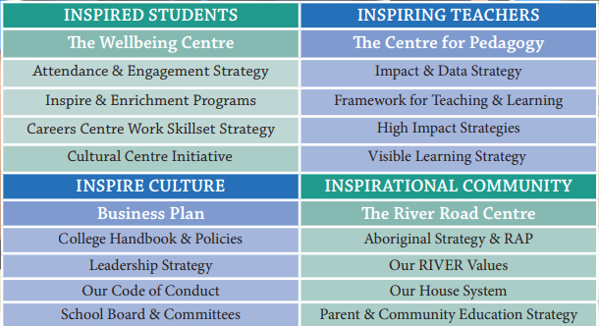

**SUPPORT SYSTEMS FOR TEACHERS AND STUDENTS**

1. **THE RIVER ROAD CENTRE** caters for complex behaviours supporting students who require Tier 3 interventions and case management.
2. **The CENTRE FOR PEDAGOGY** targets: ways of teaching and learning and is aligned to Visible Learning. The Centre is made up on leaders and teachers to support and coach our River Way Pedagogical Model of Practice.
3. **THE WELLBEING CENTRE** and team targets positive culture aligned to pastoral care activities, celebration and sense of place. The Wellbeing Centre supports the culture and pastoral care of students and staff aligned to the government’s plan creating strong communities and link to Building on Strength targeting three areas:

**OUR RIVER VALUES**

**Relationships     Identity   Virtues    Excellence   Respect**

**Southern River College is committed to be a Positive Behaviour School, promoting our values throughout our classrooms, community and practice.   We are guided by our RIVER Matrix.**

**RELATIONSHIPS - Care, Collaborative Courteous🡪**

Without positive relationships with students, teachers and our community we will only have a limited impact on changing school culture. We are the prime role models for driving positive relationships and driving positive relationships within the College. This needs to be at the forefront of everything we do and as a team

**IDENTITY - Confidence, Individuality, Pride🡪**

Who are we as a College and what identity do our students hold of themselves? We need to challenge the status quo through our programs and our pastoral care of students. Each student needs to matter, each student needs to have a positive identity that contributes to the overall image of the College and we need to empower our teachers to have the same expectations that we have of a positive identity at Southern River College. Know all students we are responsible for!

**VIRTUES - Honest Responsibility, Trust 🡪**

As a team we already live and breathe this. Our challenge is for us to empower our students and colleagues to trust us and engage with what we are trying to achieve so that they take on responsibilities for student success.

**EXCELLENCE - Aspiration, Diligence, Motivation🡪**

We need to have an invested interest in student success and what this looks like. Through our programs and our interactions with students and staff it is important that we aim to provide our students and colleagues with aspirations and the ability to achieve!

**RESPECT - Appreciation, Equality, Understanding🡪**

Taking the time to acknowledge others and to understand the whole picture before we make judgements or decisions to assist staff or students with pastoral care. We also need to find the time to find the positives where we can and acknowledge our successes and efforts and the successes and efforts of others.

**BUSINESS PLAN 2021 – 2023 |PRIORITIES AREAS AND TARGETS**

**INSPIRED STUDENTS**

**Attendance and Engagement**

* Year 9 and 10 girls’ attendance requiring better lines of inquiry as to why they are not engaging.
* Target movement in the 80% to 90%

**Students at Educational Risk**

* The River Road Centre Complex Behaviour start-up
* Case Management Processes.

**Student Pathways**

* ATAR and OLNA
* interventions and support.
* Careers Centre and whole school careers program

**STRATEGIC OBJECTIVE**

**We support every student to develop holistically and engage positively with their school community.**

**We inspire students to be challenged, to grow and succeed, to achieve their full potential on their individual learning journey.**

**Attendance and Engagement**

* Review data and implement school processes for attendance, enrolment and transition to support our whole attendance plan.
* Improve the percentage of regular attendance across all year groups, ATSI and non ATSI through the analysis of data and implementing whole school processes and strategies according to the identified need.
* Target subgroups who need greater interventions to improve school engagement.
* Identify and implement whole school programs to increase school participation and engagement.

**How will we know?**

Improved attendance to over 90% by 2023.

**Students at Educational Risk**

* The Centre for Wellbeing and Complex Behaviour Team supports students who require Tier 3 interventions and case management.
* Reduce suspensions and establish lines of enquiry to support at risk year groups.
* Students who require academic interventions are supported via educational plans and programs.
* As a culturally responsive school identify and support Indigenous and EALD equity by providing opportunities for positive engagement.

**How will we know?**

Improved suspension data – shift from 2021 data.

Survey results show pretesting to post data measuring wellbeing and academic progress

Students data shows suspension below 10%

**Student Pathways**

* Deliver a seamless education pathway that is supportive of student’s aspirations and strengths 7 to 12.
* Career Education is promoted and resourced to improve student’s understandings of career pathways, and the new work order skillset.
* Provide opportunities for students to engage in STEM Pathways and the STEM capabilities.
* Promote and implement extra-curricular extension programs to support deeper levels of learning.
* We use real life experiences to help our students apply their learning and use the general capabilities.

**How will we know?**

ATAR to mean of 70-75% + and WACE Achievement 95% +

Improved Naplan results all to high progress and achievement.

Improved OLNA above 90%

**INSPIRING TEACHERS**

**Pedagogy**

* High Impact Instructional Strategies
* Planning for languages

**Learning Environment**

* Understanding and using BUMPS effectively
* Peer Support in CMS Core Strategies

**Teaching Environment**

* High Impact Instructional Strategies
* Models of Learning

**STRATEGIC OBJECTIVE**

**We engage our knowledge of curriculum and pedagogy to inspire creativity, collaboration, empathy and innovation in a safe and supportive environment.**

**We celebrate progress and achievements throughout the school community.**

**Pedagogy**

* Visible learning is used to underpin the impact of teaching and learning across the school
* Staff regularly collect and utilise data to inform pedagogical and classroom practice
* Classroom observations are used to help support pedagogy.
* Assessment for Learning is used to monitor and inform impact and progress.

**How will we know?**

Our Visible Learning Surveys show shift in achievement and understanding of teacher impact.

OLNA, NAPLAN and RTP data inform point of need and impact of strategies.

**Learning Environment**

* Promote and share positive teaching and learning experiences and practices.
* Teachers are supported to foster a positive relationships and safe learning culture within their classrooms
* We embed a positive learning culture in a safe learning environment.
* All staff use CMS and restorative practices in their classrooms.

**How will we know?**

CMS practice is embedded throughout the school.

Assessments demonstrate point of need and interventional strategies.

**Teaching Environment**

* We use and foster a culture of research to inform our philosophy and practice about learning and teaching.
* Consistent use of common language & delivery methods across all learning areas.
* Provide opportunities for collaboration for induction, feedback, mentoring and coaching experiences.
* We engage all staff in STEM and Digital Technologies, literacy and capabilities.

**How will we know?**

Our Learning Framework and Centre for Pedagogy is part of our culture for teaching and learning.

**INSPIRE CULTURE**

**Wellbeing**

* Promote our house system and activities
* Wellbeing activities for staff and students

**Governance**

* SETQA implementation
* Communication channels and staff involvement in planning and review.
* School Review (Term 3)

**Leadership**

* Leadership Framework
* Committee Structures

**STRATEGIC OBJECTIVE**

**We believe that the culture of our school is the foundation of our practice, driven by outstanding governance, strong leadership, students and their aspirations**

**Wellbeing**

* The wellbeing of our staff and students is promoted by a strong sense of belonging as we work together to celebrate, support and care for each other.
* In collaboration with the Centre for Wellbeing Culture Team we target positive behaviours aligned to pastoral care activities, celebration and sense of place.
* Wellbeing programs are used to provide strategies to engage students. using positive education, trauma-informed and wellbeing practices that enable students' academic and personal growth.
* Staff work-life balance, social connection and engagement in our school is promoted.

**How will we know?**

Our surveys show shift in positive school culture and organisational health.

**Governance**

* We implement clear processes and strategies for school improvement that are clearly communicated, responsive, agile and informed by systemic and school-based data
* Our Code of Conduct structures are clearly defined, shared and implemented.
* Our College Board is kept informed of the school’s business and financial management processes and the impact on strategic planning and student learning.
* Committees and learning communities share and support school practice, students and teacher’s development.
* Workforce, budget and resource management practices support school planning and priorities and the Funding Agreement for Schools.

**How will we know?**

Processes and lines of communication are clearly articulated and used throughout the school.

**Leadership**

* Our culture inspires and empowers all staﬀ and students to lead, innovate and strive for excellence.
* Student voice, vertical structures are used to support student leadership, mentoring, house and pastoral care programs.
* The Future Leaders Framework is used to identify, develop and support staff and students with opportunities to lead.
* Performance development and review are used to provide feedback for staff.

**How will we know?**

Leadership across all sectors of the school is evident and shared.

Our leadership plan is established and in action.

**INSPIRATIONAL COMMUNITY**

**INSPIRATIONAL COMMUNITY**

* Families
* Parenting Programs and Connection

**Partnerships**

* Language Partnerships
* University Partnerships
* Connection with Primary Schools

**Celebration of Past, Present and Future**

* Reconciliation Plan
* Arts Centre

**STRATEGIC OBJECTIVE**

**We value and protect our sense of community, interest, action and country, that value the past, present and future of our students.**

**Our community inspires and nurtures students with partnerships, pathways of connection and learning for the future.**

**Families**

* Families are engaged in the education of their child, involved in programs and activities that support positive communication and relationships.
* Our families are offered programs that help support understanding parenting and adolescent issues.
* Our P&C and local community helps to support our families and the parent voice.

**How will we know?**

Our parent surveys show improved engagement.

**Partnerships**

* We build collaborative partnerships that promote and enhance student learning and pathways.
* Local community partnerships are encouraged and promoted to help create a sense of connection and pride.
* Educational networks and partnerships are developed to improve outcomes for students and our school community.
* Commence partnerships that support Chinese and Noongar language programs in 2022.

**How will we know?**

Partnerships are aligned to classroom enrichment, curriculum and improving student’s outcomes.

**Celebration of Past, Present and Future**

* We value our rich history and alumni and seek ambassadors: inviting connection and celebration of our school community.
* We celebrate our Aboriginal culture as part of our past, present and future.
* We develop a College communication and marketing strategy to celebrate and promote our successes.

**How will we know?**

Enrolments continue to grow stabilising over 1000.

Our Aboriginal Culture Plan is fully implemented and shows improved outcomes for students and their culture.

**OUR LEARNING FRAMEWORK**

**Southern River College supports the AITSL STANDARDS for TEACHERS and LEADERS**

* Know students and how they learn
* Know the content and how to teach it
* Plan for and implement effective teaching and learning
* Create and maintain safe and supportive learning environments
* Assess, provide feedback and report on student learning
* Engage in professional learning
* Engage professionally with colleagues, parent/carers and the community

**Our expectation for leaders in our College is based on the five ATSIL Standards for Principals**

* Leading teaching and learning
* Leading improvement, innovation and change
* Developing self and others
* Leading the management of the school
* Engaging and working with the community

**PEDAGOGICAL APPROACH TO TEACHING AND LEARNING | OUR RIVER WAY**

THE RIPPLE EFFECT | SANDCASTLES | POINT BREAKS | WATER WAYS

At Southern River College we make informed decisions about teaching and learning by using Our River Way principles of practices. This is our RIVER WAY. All staff are expected to follow and use the River Way principles of practice.

1. **The Ripple Effect uses evidence and to inform actions.** We grow and develop learning and teaching based on data. Our Ripple Effect uses purposeful feedback to improve student outcomes and see our impact.
2. **Sandcastles** are the environment we work in that support our whole school to create a positive culture. Part of our sandcastles are our RIVER Values, Good Choices, HOUSE and HOME systems. These are the building blocks of our eco-system.
3. **The Point Breaks** design and grow our teaching and pedagogical strategies providing challenge and enrichment for our students. Techniques of teaching and learning that enhance student outcomes. Points breaks demonstrate effective classroom practice and engage understandings and improve achievement.
4. Our **Water Ways** develop our connections to work, industry and further education, enhancing real world experiences and pathways that provide enriching learning opportunities. Our students set goals in their learning and career pathways and build upon a growth mindset. Parents and families support our values and celebrate with us student’s experiences and achievements.

**EXPECTATIONS AND CODE OF CONDUCT**

**As an employer of the Education Department of Western Australia all teachers are expected to familiarise themselves with the Code of Conduct which in available on the Department Website.**

**In conjunction with the code:**

As an employee, you must be familiar with the College’s policies and procedures, particularly those that apply to your work. Many of these are available online; others may be made available to you through induction, training and development programs. Please ensure you familiarize yourself with our Staff Handbook available on our intranet. If you are uncertain about the scope or content of a policy with which you must comply, you should seek clarification from the Principal or your Line Manager. You should also be familiar with the legislation under which you are employed as this may specify requirements with which you need to comply.

#### As a College employee, you are expected to:

* perform your duties to the best of your ability and be accountable for your performance
* follow reasonable instructions given by your Line Manager or his/her delegate; comply with lawful directions
* carry out your duties in a professional, competent and conscientious manner, while seeking suitable opportunities to improve your knowledge and skills, including through participation in relevant professional development
* act honestly and in good faith in fulfilling your duties
* be courteous and responsive in dealing with your colleagues, students, parents and members of the public
* work collaboratively with your colleagues
* any concerns that you may have about the safety, welfare and well-being of a child or young person; Note that this **MUST** be in accordance with the Mandatory Reporting process. Please ensure that you have completed the Child Protection Online Professional Learning Modules available through the DoE Portal.
* The College expects employees to treat each other with respect and courtesy. Our daily interaction with others reflects on the College’s reputation. Therefore, all employees are expected to be approachable, courteous and prompt in dealing with other people, including students, parents, other employees and members of the community.
* Employees who work with students have a special responsibility in presenting themselves as appropriate role models for those students. Modelling effective leadership and respect in your interactions with students can have a profoundly positive influence on a student’s personal and social development.
* As an employee you are expected to have all curriculum and assessment material completed prior to teaching your classes, providing students with the schedule of work and assessments. All staff should ensure that this is available via Connect.

#### Supervision of students

* You must take all reasonable steps to ensure that no student is exposed to any unnecessary risk of injury.
* You must be familiar with, and comply with, the College's evacuation and/or lock-in procedures.
* Students must not be left unsupervised either within or outside of class unless there is an emergency.
* You must be punctual to class and allocated supervision.
* You must remain with students at after-school activities until all students have been collected. In the event that a student is not collected you must remain with the student until collected, or seek advice from your line manager or Senior Management
* Playground supervision is an integral part of the responsibility of teaching staff. It must take precedence over other activities. It is unacceptable to be late. You must actively supervise your designated area, being vigilant and constantly moving around.
* You must be alert to bullying or any other form of discriminatory behaviour, and report incidents to the appropriate staff member, your HoLA and the Well Being Centre.

***Everal Eaton Denis Coldham***

***PRINCIPAL Board Chair***

* 1. **SCHOOL STRUCTURES & PORTFOLIOS**

Principal Everal Eaton

Deputy Principal

Sharon Harry

Deputy Principal

Owen Davies

Manager Corporate Services

Brian Hand

Deputy Principal

Frank Di Filippo

River Road Manager

Linda Daniels

Operations Manager

Sarina Cooper

Head of Well Being

Nathan Trengrove

Head of Vet

David Toothill

Head of Physical Education

Pat Warr (Acting Semester 1)

Head of Maths

Tricia Hatch

Head of English

Lesley Stace (Acting Semester 1)

Head of Science

Robert Forte

Head of Humanities

Clare Woulfe

Head of Technologies

Roze Cole

Head of Arts

Ashley Meaden

Head of SALP/TLC

Courtney Wilson

Head of STEM

Darren Smith

|  |  |  |
| --- | --- | --- |
| **1.4 PORTFOLIOS FOR SRC LEADERS** | | |
| **NAME** | **ROLE** | **RESPONSIBILITIES** |
| Everal Eaton | Principal | |
| Frank Di Filippo | Deputy Principal HR & Operations | Human Resources, Community, Transition Y6-7, Well Being Centre Deputy, Excursion Policy & Documentation, Staff Inductions Documentation |
| Owen Davies | Deputy Principal Operations, | Operations and Timetabling, WACE Tracker 11s/12s, NAPLAN, OLNA SEQTA, Operational Policy and Procedures, Surveys, SAMR, SIS/ RTP Support, SRC Handbook and Resources, Parent Communication, Computer Lab Scheduling, SEQTA, Partnerships and Staff & Student Wellbeing at SRC, |
| Sharon Harry | Deputy Principal Teaching and Learning & Senior School | SRC Curriculum and Pedagogy, Teaching & Learning, SCSA, TRBWA, ESTs, Exams, provide support positive teaching practices across the college to promote a stronger school culture and leadership at Southern River College. |
| Sarina Cooper | Operations Manager | Yard Duty, ESTs, Exams, organise resources relevant to INSPIRE. SEQTA support, OLNA and Naplan |
| Brian Hand | Manager Corporate Services | Building & Faults, Finance, Keys, Non-Teaching Staff, School Board |
| Nathan Trengove | Well Being Centre Manager | Support colleagues and students in their ongoing development of wellness programs, continue to develop, refine and promote the Southern River College RIVER values. Organise resources relevant to wellbeing and a positive school culture. |
| Linda Daniels | River Road Manager | Tier 3 students management and over sight, Well Being Centre Support, SAER, student individual plan creation |
| Tricia Hatch | HoLA of Maths | Maths |
| Lesley Stace | HoLA of English | English |
| Robert Forte | HoLA of Science | Science |
| Clare Woulfe | HoLA of HASS | HASS |
| Courtney Wilson | HoLA of SALP/TLC | SALP program |
| Roze Cole | HoLA Technologies | Digital Technology, Design & Technology & Food & Technology |
| Ashley Meaden | HoLA of Arts | Arts, Arts Festivals, Music Concerts |
| Patt Warr | Head of Physical Education | Health, Physical Education |
| David Toothill | HoLA VET | Career Advice, Coordinator and Certificate II Courses, Design and Technology ,External  Certificate Courses, GETIL, Try a Trades, VET |
| Darren Smith | HoLA STEM | STEM |

#### 1.5 STAFF LIST

School environments are a forever changing place, as to are staff for various reasons. The most accurate copy of the staff list and telephone extension can be found on the SRC Staff SharePoint page. To access this simply log into SEQTA, select Splashpage, select SRC Splashpoint, Click the folder Staff phone contact list

Below is the link

<https://educationwaeduau.sharepoint.com/:f:/r/teams/4121.AllStaff.Team/Shared%20Documents/Staff%20Phone%20Contact%20List?csf=1&web=1&e=8b8c2M>

**1.7 COLLEGE MAP**

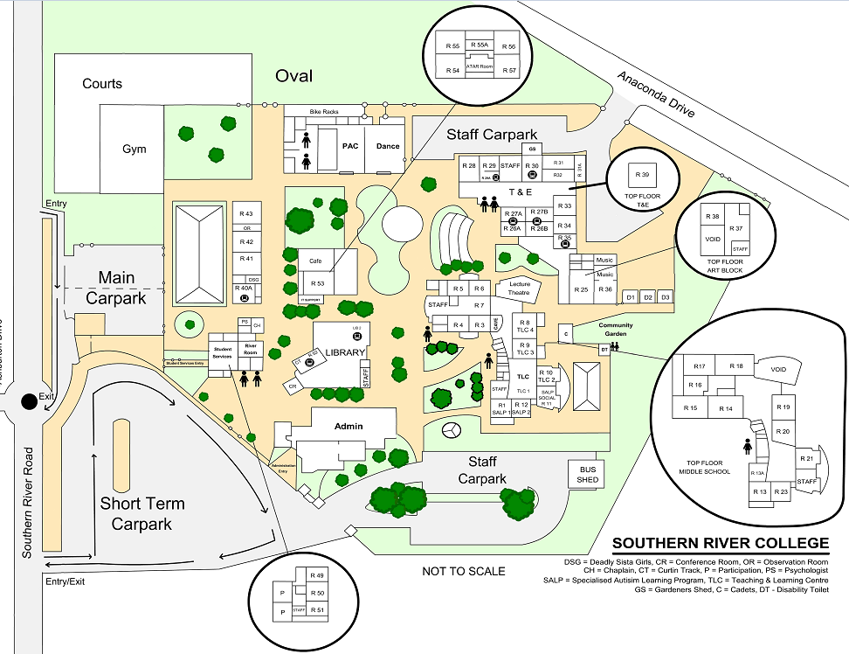

**OPERATIONAL**

* 1. **SCHOOL DAY CONFIGURATION Monday & Wednesday**

|  |  |  |  |  |  |  |  |  |  |  |  |  |  |  |  |  |  |  |  |  |  |  |  |  |  |  |  |  |  |  |  |  |  |  |  |  |  |  |  |  |  |  |  |  |  |  |  |  |
| --- | --- | --- | --- | --- | --- | --- | --- | --- | --- | --- | --- | --- | --- | --- | --- | --- | --- | --- | --- | --- | --- | --- | --- | --- | --- | --- | --- | --- | --- | --- | --- | --- | --- | --- | --- | --- | --- | --- | --- | --- | --- | --- | --- | --- | --- | --- | --- | --- |
| **House Group**   |  |  |  |  | | --- | --- | --- | --- | | **Monday & Wednesday** | | | | | **Start 8.40am Finish 2.50pm** | | | | | **8.35 -** | **To** | **Courtesy Siren** |  | | **8.40 –** | **9.40** | **Period 1** | 60min | | **9.40 –** | **10.40** | **Period 2** | 60min | | **10.40 –** | **11.05** | **Lunch 1** | 25min | | **11:05** | **11:25** | **Homeroom** | 20min | | **11.25 –** | **12.25** | **Period 3** | 60min | | **12.25 –** | **13.25** | **Period 4** | 60min | | **13.25 –** | **13.50** | **Lunch 2** | 25min | | **13.50 –** | **14.50** | **Period 5** | 60min | |  |  | After school (Duties and operational time) | | |
|
|
|
|
|
|
|
|
|
|
|
|

* 1. **SCHOOL DAY CONFIGURATION Tuesday & Friday**

|  |  |  |  |  |  |  |  |  |  |  |  |  |  |  |  |  |  |  |  |  |  |  |  |  |  |  |  |  |  |  |  |  |  |  |  |  |  |  |  |  |  |  |  |  |
| --- | --- | --- | --- | --- | --- | --- | --- | --- | --- | --- | --- | --- | --- | --- | --- | --- | --- | --- | --- | --- | --- | --- | --- | --- | --- | --- | --- | --- | --- | --- | --- | --- | --- | --- | --- | --- | --- | --- | --- | --- | --- | --- | --- | --- |
| **Early Close Tuesday & Friday**   |  |  |  |  | | --- | --- | --- | --- | | **Tuesday & Friday** | | | | | **Start 8.40am Finish 2.30pm** | | | | | **8.35 -** | **To** | **Courtesy Siren** |  | | **8.40 –** | **9.40** | **Period 1** | 60min | | **9.40 –** | **10.40** | **Period 2** | 60min | | **10.40 –** | **11.05** | **Lunch 1** | 25min | | **11.05 –** | **12.05** | **Period 3** | 60min | | **12.05 –** | **13.05** | **Period 4** | 60min | | **13.05 –** | **13.25** | **Lunch 2** | 25min | | **13.25–** | **14.30** | **Period 5** | 55min | |  |  | After school (Duties and operational time) | | |
|
|
|
|
|
|
|
|
|
|
|
|

* 1. **SCHOOL DAY CONFIGURATION Thursday 6 Period day**

|  |  |  |  |  |  |  |  |  |  |  |  |  |  |  |  |  |  |  |  |  |  |  |  |  |  |  |  |  |  |  |  |  |  |  |  |  |  |  |  |  |  |  |  |  |  |  |  |  |
| --- | --- | --- | --- | --- | --- | --- | --- | --- | --- | --- | --- | --- | --- | --- | --- | --- | --- | --- | --- | --- | --- | --- | --- | --- | --- | --- | --- | --- | --- | --- | --- | --- | --- | --- | --- | --- | --- | --- | --- | --- | --- | --- | --- | --- | --- | --- | --- | --- |
| **Thursday - 6 Period Day**   |  |  |  |  | | --- | --- | --- | --- | | **Thursday** | | | | | **Start 8.40am Finish 2.50pm** | | | | | **8.35 -** | **To** | **Courtesy Siren** |  | | **8.40 –** | **9.35** | **Period 1** | 55min | | **9.35 –** | **10.30** | **Period 2** | 55min | | **10.30 –** | **10.55** | **Lunch 1** | 25min | | **10.55 –** | **11.50** | **Period 3** | 55min | | **11.50 –** | **12.45** | **Period 4** | 55min | | **12.45 –** | **13.05** | **Lunch 2** | 25min | | **13.05–** | **14.00** | **Period 5** | 55min | | **14.00** | **14:50** | **Period 6** | 55min | |  |  | After school (Duties and operational time) | | |
|
|
|
|
|
|
|
|
|
|
|
|

* 1. **KEY DATES FOR 2022**

**\*Dates are subject to change. For a more accurate breakdown of College events refer to the SRC Term Calendars**

**located on the SEQTA Splash PAge.**

|  |  |
| --- | --- |
| TERM 1 | |
| Professional Development Days | 28th January & 29st January |
| Start of the School Year | 1st February |
| Professional Development Day | 4TH March |
| Labour Day Public Holiday | 7th March |
| OLNA | 28th Feb – 18th March |
| Last Day of Term 1 | 1th April |
| *Term Break 11th April - 25th April* | |
| TERM 2 | |
|  |  |
| Start of Term 2 | 26th April |
| ESTs | 2nd May -13th May |
| NAPLAN | 11th May - 21st May Online |
|  |  |
| Year 10, 11 & 12 Exams | 30th May- 3rd June |
| WA Day Public Holiday | 6th June |
| Last Day of Term 2 | 1st July |
| *Term Break 4th July - 17th July* | |
| TERM 3 | |
| Start of Term 3 | 18th July |
| Professional Development Days | 18th July & 26th Aug |
| OLNA | 30th August – 17th September |
| Last Day of Term 3 | 23rd September |
| Year 12 ATAR Mock Examinations | 5th – 8th October |
| *Term Break 26th September - 9th October* | |
| TERM 4 | |
| Start of Term 4 | 10th October |
| Last Day of the School Year | 16th December |
|  |  |
| *School recommences in February 2023* | |

* 1. **DUTY AREA RESPONSIBILITIES**

**Yard Duty Procedures 2022**

You will be asked to perform two thirty-minute duties, or the equivalent of (morning duties and afternoon duties have a duration of 15 minutes).

Teachers assigned the roving duty will be Heads of Learning Area, teaching staff with leadership positions and long-standing teachers within the College.

Please make yourself aware of the **Duty Roster Map** as well as the **Student Area Allocation Map** to ensure your supervision is accurate.

In general, when on duty:

* Please **be on time** to your duty, be active and do not stay in one place. Do not take a cup of tea/coffee out on duty with you as you are actively supervising
* Wear the issued high visibility vest. Take your Learning Area walkie-talkie on duty and have your walkie-talkie on **channel 18**. This is an OH&S issue.
* Encourage students to put their rubbish in the bin as you move around.
* Know who is on duty in the areas near you. Please don’t congregate and chat as this leaves areas unsupervised.
* Be vigilant for potentially dangerous or anti-social behaviour. Use low key responses to diffuse situations before they occur.
* Please talk to the Rover on duty if you perceive an incident may escalate or have any queries.
* If a situation occurs that requires immediate action, inform your neighbouring colleague and contact the Well Being Centre/ River Road office or Administrative office for assistance.
* Be aware of the ‘out of bounds’ markings/boundaries, walk through areas and ensure students are directed by them.
* Advise any students on mobile phones/laptops to put them away. Laptops must be used in the Library during lunch breaks.

**Responsibility of the Rover:**

* **The Rover is responsible for ensuring all scheduled teachers are present and actively engaged in supervision of their assigned area.**
* The Rover will assist teachers in dealing with any issues which may arise while on duty.
* The Rover will bring to the attention of the appropriate member of Student Services or Administration if any unresolved issues from their duty for follow up.
* **Rover 1** covers Year 9 and 8 duty areas (including basketball courts), the oval, the gym and monitoring Y10,11 and 12 Area
* **Rover 2** covers Year 7, duty areas, SALP, Canteen, Library and the Y10,11 and 12 Area

**DUTY AREAS:**

**DUTY AREA - LIBRARY & HELP DESK:** Please touch base with Library staff and Ms Cole regarding expectations of student behaviour in the library. In general, this is a quiet area; no bags, food or drink.

The Student Help Desk will be in LIB2 to assist students with ICT issues.

Curtin Track is for Year 11 & 12 students to do quiet study.

**FRONT OVAL/GATE:** Our image presented to the community is important. To assist with the management of students entering and exiting the school at the start and the end of the day, it is essential that duty staff arrive on time in this area. The zone of the front oval/gate duty extends from the front of school bus stop to the far car park boundary fence closes to the Pat Morris Pavilion.

* Please position yourself at the front of Student Services so that you can see all front entries to the college
* Please monitor activity through this area and deal with undesirable activity appropriately (i.e. students on bikes in the kiss and drop area)
* Please open and lock gates where appropriate pre and post duty. Locking of the gate should be after completion of your duty time

**BACK OVAL/GATE:** Our image presented to the community is important. To assist with the management of students entering and exiting the school at the start and the end of the day it is essential that duty staff arrive on time in this area. The zone of the back oval/gate duty extends from the back of school gate to the back of school bus stop.

* Please position yourself near the back oval fence (not the gate) so that you are proximal to the bus stop
* Maintain safety of students crossing the road
* Please monitor activity through this area and deal with undesirable activity appropriately (i.e. students smoking at the bus stop)
* Please open and lock gates where appropriate pre and post duty. Locking of the gate should be after completion of your duty time

**DUTY AREA CANTEEN & COMMON CAFÉ AREA:** The canteen has the potential to be very hectic, especially for the first 15 minutes. It is essential that duty staff arrive on time in this area.

* Please ensure students enter in an orderly fashion and display expected conduct
* Please address students who may be eliciting money; they are to be asked to leave the Café area immediately
* Students who are not sitting at tables or ordering food should not linger in the area, e.g. if they are not buying food, they’re not inside the cafe
* Use low key CMS strategies to deescalate behaviour
* Please monitor the outdoor common café area and make sure all rubbish is placed in bins

**DUTY AREA - GYM:** Generally, staff are allocated duty in this area to ensure that the equipment and facilities are appropriately used.

* HPE staff have a year group roster for the use of the gym during lunch 1 and lunch 2
* Students are required to be in full school uniform to access the Gym
* Staff on duty will also distribute equipment for gym, oval and basketball courts for all year groups
* Food, eating or drinking is not permitted in the gym
* Student bags will not be exchanged for equipment - bags are to be placed inside lockers
* Check toilets located in this area
* Address any unsafe or rough play during the lunch 1 and lunch 2 breaks in the gym

|  |  |  |  |  |
| --- | --- | --- | --- | --- |
| **M Monday L1/L2** | **Tu Tuesday L1/L2** | **W Wednesday L1/L2** | **Th Thursday L1/L2** | **Fr Friday L1/L2** |
| Y11/12s | Y7s | Y8s | Y9s | Y10s |

**DUTY AREA- OVAL/BASKETBALL/NETBALL COURTS:** Students accessing these areas at break times are very keen to make the most of their break; please ensure that you are arriving promptly to this duty area and monitoring access by students vigilantly.

* Ensure the oval and the courts are manned by allocated staff member before unlocking the gates
* All students are required **to be in school uniform to access the oval and court spaces**
* Food is not permitted to be taken onto the oval or the courts; water bottles are to remain in bags
* Bags are required to be left outside the oval and courts, by the fence line
* Students are required to be active when using the spaces. Please encourage students to play sport, walk laps or engage positively with activities
* **Rough play and tackle sports are not permitted**
* Seek support from Rover on duty to assist with student management

**DUTY AREA –Year 7 AREA:** Please supervise the centre courtyard. Please ensure that Year 7s are only **using the area are and are in the correct spaces**.

* Please monitor students using spaces close to the staff car park; no ball games or student activity is to occur in the staff car park - please move students on.
* Sports games (excluding 4 Square) and running/chasey games are to be played on the oval
* Be active in the area, ask students to collect their rubbish and place it in the bins
* Please monitor the walkway along the Deputy offices - **this are is Out of Bounds to students and students should not be sitting in this area**
* Please check the toilets regularly and ensure that students are not loitering in the space

**DUTY AREA – Year 8 AREA:** Please supervise the area around the lawn and walled gardens on the oval side of the gym (up to edge of undercover area), the small grassed court yard between PAC and Café building and the corridor to Room 40A

* **Please ensure that Year 8’s are only using this area**
* Monitor and move through the walled garden space and be active; request students to place rubbish in bins
* Check toilets located at PAC
* **Sports activities are not to be played on this lawn area**. Please ask students to move to the oval, the courts or the gym as appropriate
* Please ask for Rover support as/when necessary

**DUTY AREA – Year 9 AREA:** Please supervise the area between the back of WellBeing Centre. Please ensure that Year 9s are only using the area.

* Check toilets attached to Student Well Being Centre
* Remind students to collect their rubbish and place in bins provided
* Ensure that student stay out of the garden boxes to maintain the garden area
* Be active and monitor walled garden spaces to ensure duty of care is present
* **Sports activities are not to be played in this space** (excluding 4 Square). Please ask students to move to oval, courts or gym as appropriate

**DUTY AREA – Year 10/11/12 AREA:** Please supervise the T&E lawn, amphitheatre area and the area surrounding the cadet shed

* **Please ensure only Year 10/11 AND 12’s are using this area**
* Please monitor the inside corridors of the Arts/Media and Design Technology buildings - students are not permitted to sit or use these spaces during break times
* Check to see that students have not entered the middle school building and temporarily lock the middle school doors
* Check toilets located in this area
* Be active in the area, ask students to collect their rubbish and place in the bins
* Sports games (excluding 4 Square under the amphitheatre roof) and running/chasey games are to be played on the oval

Please see **Duty Area Map** and **Student Area Allocation Map** attached to ensure your supervision is accurate.

#### DUTY AREA MAP



2022

* 1. **NEW STAFF INDUCTION & IN-HOUSE PD REQUIREMENTS**

|  |  |  |  |  |
| --- | --- | --- | --- | --- |
| SRC has its own particular curriculum and operational dynamics. To assist new teachers in becoming “inspiring” teachers there are in-house PDs/workshops that new staff must complete in order to better understand the SRC way. All this information is also contained within the SRC handbook.  By completing these PDs/workshops the College is able to offer new teachers additional support in areas that they might need and can’t access freely from other staff. If a new staff member has proficiency in one of these areas then they need to demonstrate this to the deputy or representative responsible for the PD/workshop.  Below is the checklist and sign off sheet new staff need to complete as part of their induction at SRC. | | | | |
|  | **PD WORKSHOP** | **APPROXIMATE TIMEFRAME** | **DEPUTY/REPRESENTATIVE**  **SIGNATURE & DATE** |  |
|  | New Staff and Mentor Meeting | Term 1 25th Janruary |  |  |
|  | SEQTA and Attendance | Term 1 25th Janruary |  |  |
|  | SRC Conduct Policy | Term 1 February 7th |  |  |
|  | SharePoint/SIS/RTP | Term 1 February 14th |  |  |
|  | HouseSystem | Term 1 February 14th |  |  |
|  | Explicit Direct Instruction taster | Term 1 February 28th |  |  |
|  | Duty | Term 1 March 14th |  |  |
|  | Lockdown | Term 1 March 14th |  |  |
|  | Excursion Packages | Term 1 March 14th |  |  |
|  | EST/NAPLAN/Exam Invigilation | Term 1 March 28th |  |  |
|  | Reporting | Term 2 May 19th |  |  |
|  | Evacuation | Term 2 June 9th |  |  |
|  | Classroom Management Strategies Workshop  (SNAPSHOTS) | Term 1 & 2 (fortnightly workshops) |  |  |
|  | ***SRC INDUCTION COMPLETED SIGN-OFF SECTION*** | |  |  |

* 1. **ATTENDANCE**

For all the information on attendance please refer to the Attendance Policy in section 6.2

Key information from the policy:

The Department of Education monitors and manages student attendance in order to maximise the opportunities for all students to learn.

It is the Principal’s responsibility to keep an accurate attendance record for every student enrolled at the school and to note whether a student’s absence is authorised or unauthorised.

Classroom teachers therefore have a responsibility to record attendance accurately, maintain a record of attendance for the students they teach and record authorised or unauthorised absentees if they are an Inspire Teachers. Below are attendance guidelines teachers need to follow.

**CLASSROOM TEACHERS:**

1. Lesson attendance is to be taken in the first 15 minutes of each lesson via SEQTA (online attendance system). Teachers are required to update their attendance accordingly should students move in or out of the class.
2. Teachers are to keep and maintain accurate classroom and attendance records for seven years in accordance with School Education, Regulations 2000 and the Retention and Disposal Schedule for DoE School, College and Campus Records
3. Late arrivals must sign in at Welling Being Centre so that an arrival time can be recorded accurately on SEQTA. Students will have an SEQTA paper note proving their lateness has been recorded
4. Unauthorised lates or departures from class by a student is required to be recorded on SEQTA.
5. **Parents need to be contacted if student absence exceeds three consecutive breaches for your class to verify the cause and discuss the impact that this has on a student’s education.**

**HOUSE ROOM TEACHERS (**Monday and Wednesday**)**

1. Homeroom teachers to follow up on unauthorised attendance (steps on how to do this are located in the attendance policy).
2. Collect notes explaining absenteeism and provide them to the Well Being Centre.
3. Use distributed weekly Form Absentee Reports to follow up on and target unauthorised student absences.
4. Parents are contacted for non-verified absences following the follow up of the weekly absentee report
5. Teachers are to inform Student Services if they make parent contact and have an explanation for a student’s absence.

6. **Perform a Student At Educational Risk (SAER) process for students with persistent unauthorised absences**

1. Section 3

#### Seqta emailsSEQTA



SEQTA is the online attendance and pastoral system we use at Southern River College. It can be accessed via the staff portal page

<https://teach.southernrivercollege.wa.edu.au/welcome>

[SPS video - SEQTA Teach - The attendance management process](https://www.youtube.com/watch?v=sk07-3WCaMc&feature=emb_logo)

**SEQTA Roll Marking Screen**

There are several areas in SEQTA Teach where attendance can be recorded and managed.

These areas are detailed below:

The **Attendance** **Roll** sub-page

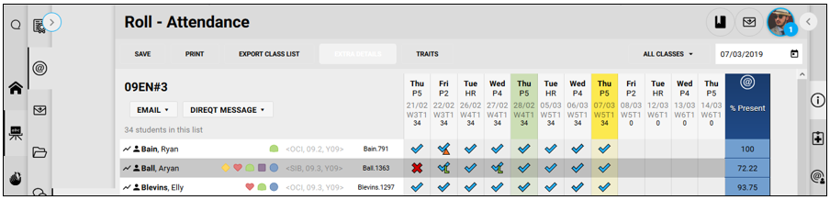

The Student information panel, the View attendance history pane

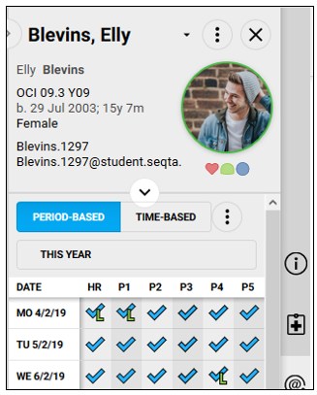

Teachers access an attendance roll from their **Timetable** page. The **Roll**sub*-*page is designed to reflect a traditional roll book view that most teachers are familiar with, providing

a quick overview of attendance data, including upcoming attendance events, and showing trends in attendance, e.g. non-attendance on days scheduled for tests.

1. Navigate to the**Teaching** workspace, click the **Timetable** page, click either the **My day, My classes, Traditional view** or **Calendar** sub-pages.
2. Click the **Load attendance** icon for the relevant class.
3. Students are listed in alphabetical order with the total number of students indicated at the top.
4. If a student has an alert it will appear as a graphical indicator to the right of the student name. Hover over an alert to view the alert details. Alert icons can be hidden by clicking the **Extra details** button in the toolbar. Further details on the alert icons are available at the end of this quick guide.
5. Student attendance shows rolls as marked, and attendance resolutions including those entered in advance. Hover over an attendance resolution to display the details.
6. If the corresponding programme contains assessments, green columns will display to indicate an assessment due date. This is useful to identify absence trends.

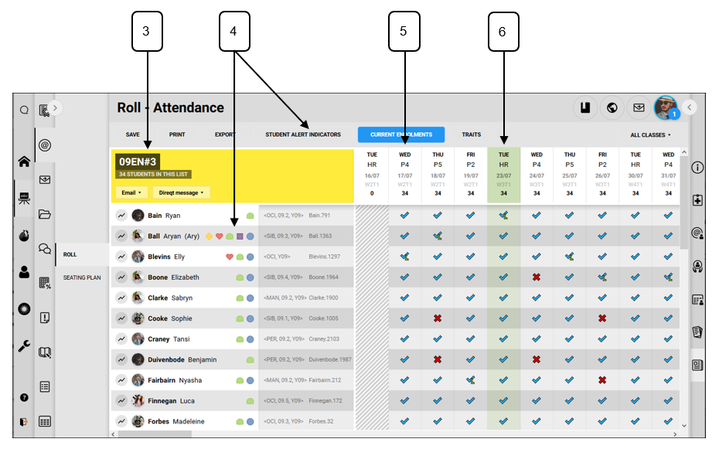

1. Commonly needed administrative documents, e.g. student lists, student photo sheets, etc.can also be generated as PDF documents from the **Print** button on the toolbar.
2. A period occurring at the current time will display as a coloured column.
3. Where multiple classes are attached to the same programme, attendance for other classes can also be viewed and marked using the class selector in the toolbar.
4. If a school has enabled the calculated attendance column, it will be visible on the very right-hand side of the roll. Schools have the ability to select the calculation type. Further details are available at the end of this quick guide.

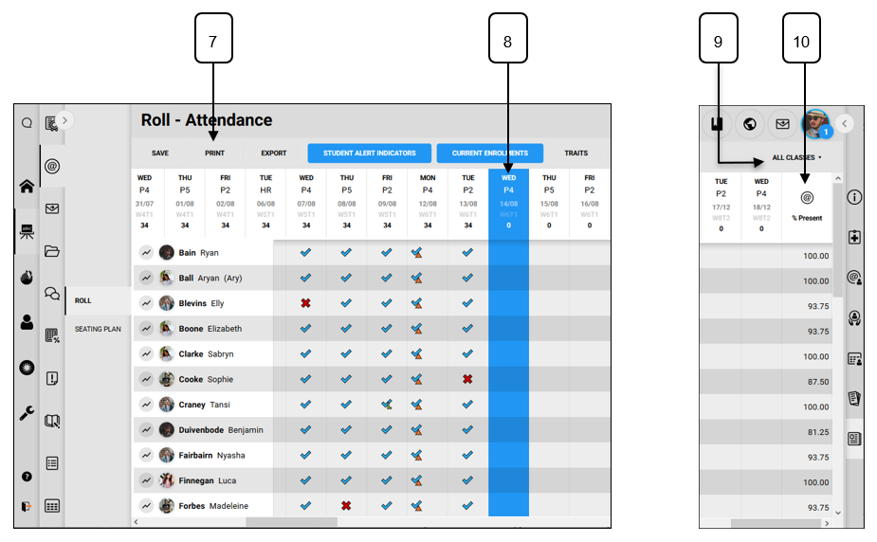

Further details - Student Alert icons

Student alert icons are present in most places in SEQTA Teach where the student’s name appears. These are intended to alert staff to the fact that there is information important to a student’s welfare or academic support requirements.

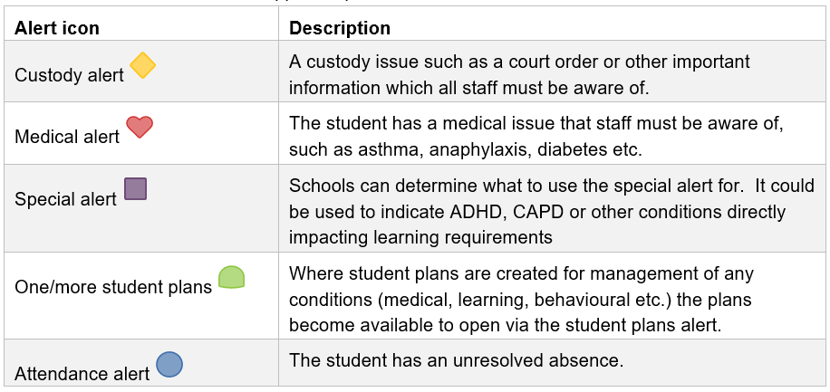

3.2 SEQTA Student Information

Located on the right-hand side of the screen is the **Student Information Panel (SIP).**  The **Student Information Panel (SIP)** consists of seven panes, six of which give access to student information, including contact details, emergency details, custody details and medical details. There are also tools to enter pastoral care records, view attendance history, academic reports and timetables.

The last pane is the **News** pane and by default is populated with SEQTA news regarding new release, upcoming events and training. Schools can customise the news pane and display school specific or other information if required.

1. From anywhere in the software, click the **Expand/collapse the SIP**button.

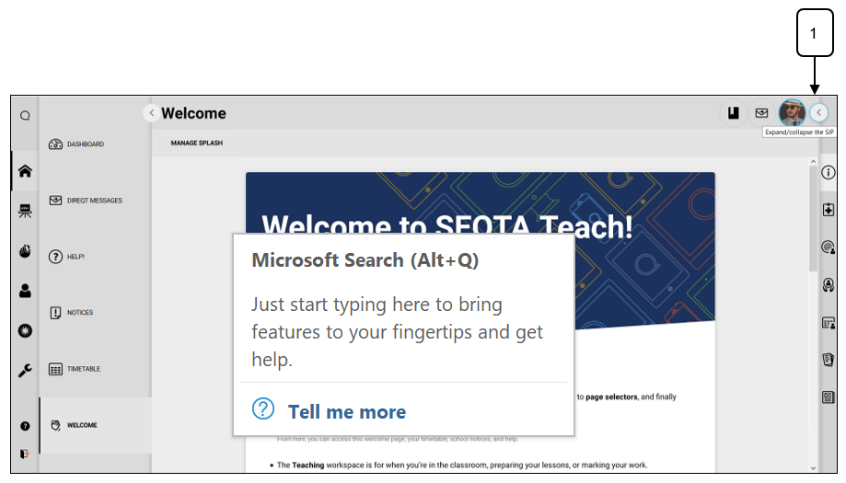

1. Select a student.
2. Use the buttons on the right to move between the different panes.

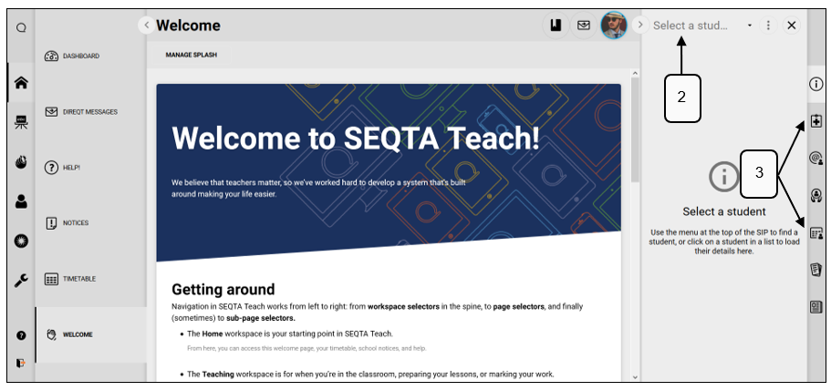

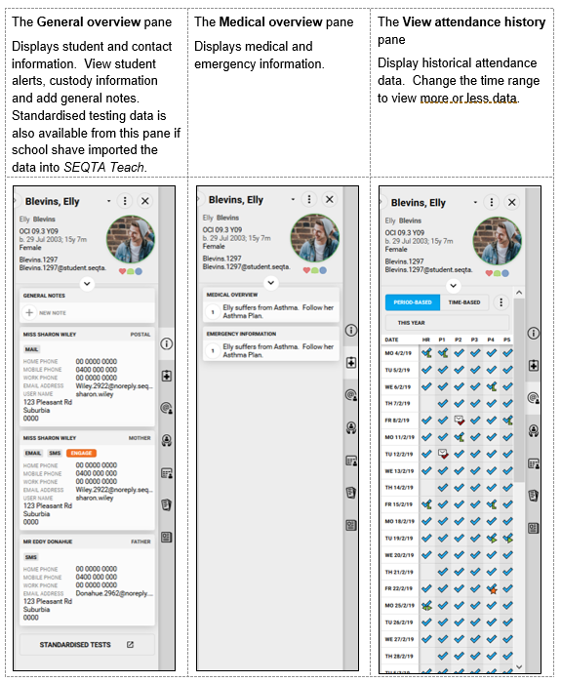

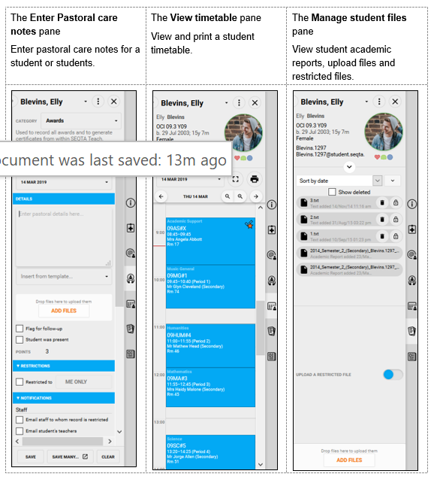

#### EXCURSIONS

When coordinating an incursion or excursion it must link to the College business plan or have an educational purpose. If your excursion meets these criteria, then you need to complete an excursion policy package (Section 6.2).

There are also other steps that need to be followed in order to have your incursion/excursion approved. These steps are:

1. Complete the excursion policy package, ensuring that you have also collected any relevant information (PLI, evacuation procedures etc.)
2. Have your HoLA or line manager check the package information, approve of the costings and sign off on the excursion
3. Your HoLA then needs to submit the package to Leaders for approval **4 weeks prior to the excursion.** This allows for a Deputy Principal to look over the documentation and the Principal to approve the excursion.
4. Wait for HR Officer to provide you with incursion/excursion permission forms for your incursion/excursion to provide a copy to students. This ensures that the correct information goes out to parents/care givers and that all permission forms look the same and match the Colleges insignia

Once your excursion is approved you need to:

1. Ensure students are handing in their excursion forms and fees if applicable
2. That you have an attendance record for the students attending the excursion and that all these students have provided their excursion forms
3. That an attendance record is submitted to the Well Being Centre if the incursion/excursion will affect a student’s normal day attendance.
4. Submit all paperwork back to the HR officer once the incursion/excursion is complete (including permission forms)

Further information and resources are available in the SRC Sharepoint

SEQTA Splashpage > SRC Sharepoint >Excursion Policy

Link > <https://educationwaeduau.sharepoint.com/:f:/r/teams/4121.AllStaff.Team/Shared%20Documents/Excursion%20Policy?csf=1&web=1&e=jlrK4B>

* 1. **EVACUATION PROCEDURES**

For step by step information in an Emergency Situation, please refer to the Emergency Procedures Handbook section 6.2. This section of the handbook only provides a brief overview of Evacuation Procedures.

Overview

Different types of events may lead to the need for a whole-school evacuation. In the case of evacuation the following processes will occur:

1. The need for an evacuation will be determined and initiated by the Principal or the Principal’s delegate only
2. The Principal or Principal’s delegate will activate the appropriate Emergency Response plan for the incident
3. A message requesting staff and students to evacuate the College will sound over the PA in combination with sirens
4. Teaching staff are to escort their class along their designated evacuation route or the safest route possible. If a teacher has other responsibilities in the case of an emergency (ie Floor warden) then they are to hand their class over to another teacher and assume the role in emergency situation
5. Teachers will take their class to the designated assembly area; **“lawn next to the New** **Gymnasium,**” and help with the organisation of classes and year groups. Classes to be seated in paired lines.
6. Teachers are then to wait for further instructions

Please familiarise yourself with the Emergency Procedures Handbook on Connect.

SEQTA Splashpage >SRC SharePoint> Polices

Link is > <https://educationwaeduau.sharepoint.com/:f:/r/teams/4121.AllStaff.Team/Shared%20Documents/SRC%20Policies?csf=1&web=1&e=2Eg0Ii>

#### LOCKDOWN PROCEDURES

For step by step information when Lockdown procedures are activated, please refer to the Emergency Procedures Handbook section 6.2. This section of the handbook only provides a brief overview of Lockdown Procedures.

Overview

Different types of events may lead to the need for a whole-school evacuation. In the case of evacuation, the following processes will occur:

1. The need for a Lockdown will be determined and activated by the Principal or the Principal’s delegate only
2. The Principal and the Principal’s delegate will activate the appropriate Lockdown response
3. In the case of a whole school lockdown continuous sirens will sound, or a discrete message will be put over the PA system
4. The discrete messages are as follows

*MR YELLOW MR YELLOW MR YELLOW, please can you make your way to the front office, MR YELLOW MR YELLOW MR YELLOW* (to be used for a general lockdown, teachers should lock all exits and ensure students do not open doors or leave the classroom). Await further instructions.

*Ms BLACK Ms BLACK Ms BLACK, please can you make your way to the front office, Ms BLACK, Ms BLACK, Ms BLACK* (to be used for a lockdown requiring students to be on the ground, curtains closed and lights off). Await further instructions.

1. Teaching staff are to lock external exits to their classrooms and ensure that they do not allow students to enter or exit the classroom. If a teacher has other responsibilities in the case of a Lockdown (ie Floor warden) then they are to hand their class over to another teacher and assume the role in a Lockdown situation, if it is safe to do so.
2. Teachers will take their class to the designated assembly area on the back oval, if instructed to do so and help with the organisation of classes and year groups on the oval. Classes to be seated in paired lines.
3. Teachers are then to wait for further instructions

Please familiarise yourself with the Emergency Procedures Handbook to access more information on Lockdown Procedures.

1. SEQTA Splashpage >SRC SharePoint> Polices
2. Link is > <https://educationwaeduau.sharepoint.com/:f:/r/teams/4121.AllStaff.Team/Shared%20Documents/SRC%20Policies?csf=1&web=1&e=2Eg0Ii>

#### COMMUNICATION- Connect, Dashboard, Facebook, Daily Notices & Weekly Reflections

|  |  |  |  |
| --- | --- | --- | --- |
| SRC utilised a multitude of communication strategies to ensure students, staff and parents receive specific messaging from the College. Please see the list of different communication strategies below and how they can be used by you for accessing College information. | | | |
|  | Daily Notices Via SEQTA | Daily notices are placed on SEQTA (home page) each afternoon for the following day.  Daily notices contain information for students about upcoming events and important activities occurring across the College.  To get to the daily notices -> Click home page> Notices    Guidelines for communicating and submitting Daily Notices:   * Read out daily notices to class Period 1 * If you wish to place a message into the daily notices the Administration Officers need to be informed by 13:00pm the day before * Please set a timeframe for how long you would like your message to remain in the daily notice |  |

|  |  |  |  |
| --- | --- | --- | --- |
|  | Splash Page | The SEQTA Splash page is your one to access All key information from SEQTA with a click of button- from Ikon, DET Intranet, Room and Resource booking, Connect, TV4Education, duty rosters, School Policies and Papercut.  **If you have an ICT click on the “southern River Intranet’ hyperlink**  This features the IT ticket online system. If you are having an issue with your software, hardware or connectivity this is the best way to have the problem resolved by an IT technician. Simply submit your issue via the ticketing system and a technician will be assigned to assist you with your IT issue.  To access the dashboard please go to the following address:  [**http://intranet.southernrivercollege.wa.edu.au**](http://intranet.southernrivercollege.wa.edu.au/) |  |
|  | Facebook | The College has a Facebook page which it uses for promotion of College events, Staff/Student recognition and all the wonderful programs the College offers. If you would like to place something on the College Facebook account, you need to submit your item through the dashboard or contact librarian officer Mrs Shiarne Coole. |  |
|  | Leaders Minutes | Leaders attend 2 meeting per week, with one week focusing on Curriculum and Operational matters across the College. These minutes are made available to staff via Teams and key information is communicated to staff via HoLA’s at their learning area meetings. Please check the minutes to see what is going on in the College and raise your thoughts and ideas on particular issues through your HoLA. |  |
|  | Learning Area Meetings | Each week you will have a designated Learning Area Meeting time set out by your HoLA. In these meetings you will be briefed about leaders meetings and discuss  issues important to your Learning Area. |  |
|  | Newsletter | The newsletter goes out twice a term to our Community and Feeder Primary Schools. If you wish to submit an article for the newsletter, please submit the article via email or contact the PR/Marketing Officer Julie Hughes. |  |
|  | PA | The PA is used for communicating the start and beginning of periods (bell), emergency situations (sirens), and important messages that need to be delivered quickly to the whole College.  If you require an announcement to be placed over the PA, please seek permission from a Deputy Principal. |  |
|  | SRC Sharepoint | The SRC Sharepoint contains all the information contained in this handbook as well as other Operational information for the effective running of the College.  As an SRC staff member you will be given access to the Sharepoint, but if you have any difficulties in accessing the Community then please contact Owen Davies  <https://educationwaeduau.sharepoint.com/teams/4121.AllStaff.Team/SitePages/TrainingHome.aspx> |  |

* 1. **LEADERS MEETINGS**

There is two Leaders meeting per week, focusing on Curriculum aand Operational matters across the College. The Curriculum Leaders Meeting focuses on curriculum development and pedagogy to raise the standard of teaching and raise the standard of student learning across SRC. The Operations matters focuses on the running of the College and the day to day activities and information that is required to achieve this. Your HoLA attends Leaders meetings as your representative and feeds back information to you via your learning area meetings.

If you would like items from this meeting further clarified or to raise your ideas or opinions about topics that come up in either meeting, then speak to your HoLA who will feedback that information to other Leaders at the next meeting.

* 1. **PD Days & STAFF MEETINGS**

PD Days and Staff Meetings have been set aside for whole school planning and staff development. They provide valuable learning opportunities and a chance to discuss and clarify where SRC is headed and what role you play in this direction as a staff member. Attendance for either event is compulsory and permission must be sort from the Principal in person if exceptional circumstances will prevent you from attending either a PD Day or Staff Meeting.

PD Days are as follows:

|  |  |  |
| --- | --- | --- |
| TERM 1 | | |
| Professional Development  Days | 27th January & 28th January | Focus for 2022, Pedagogy and SEQTA Curriculum |
| Professional Development  Day | 4th March | Staff Planning – LA Planning Day |
| TERM 3 | |  |
| Professional Development  Day | 18th July | Pedagody |
| Professional Development  Day | 26th August | Pedagody |

Staff meetings:

* Are generally held four times a term for an hour /hour and half and are on the Term planner
* The time is attributed to trading-off the last day of the school year and EBA requirements
* If you miss a staff meeting due to exceptional circumstances, you must discuss with the Principal. You may be required to make up the trade-off time or be required to attend on the last day of school

#### SRC SharePoint

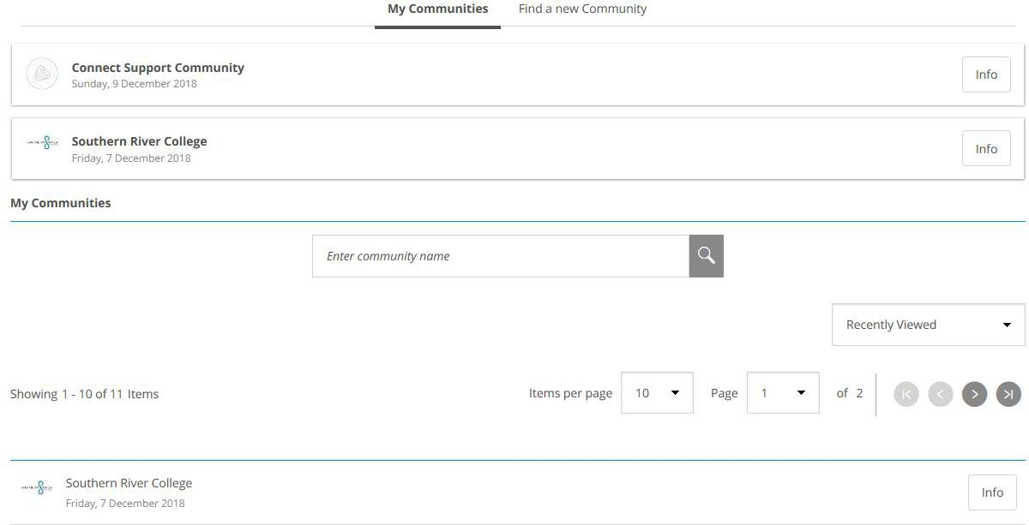

As a staff member you will automatically be connected to the SRC SharePoint page. The page contains any Operational information regarding the College you may require, plus all the information located in this handbook.

To access the community page log into SEQTA and click on one oftheicons to be hyperlinked.

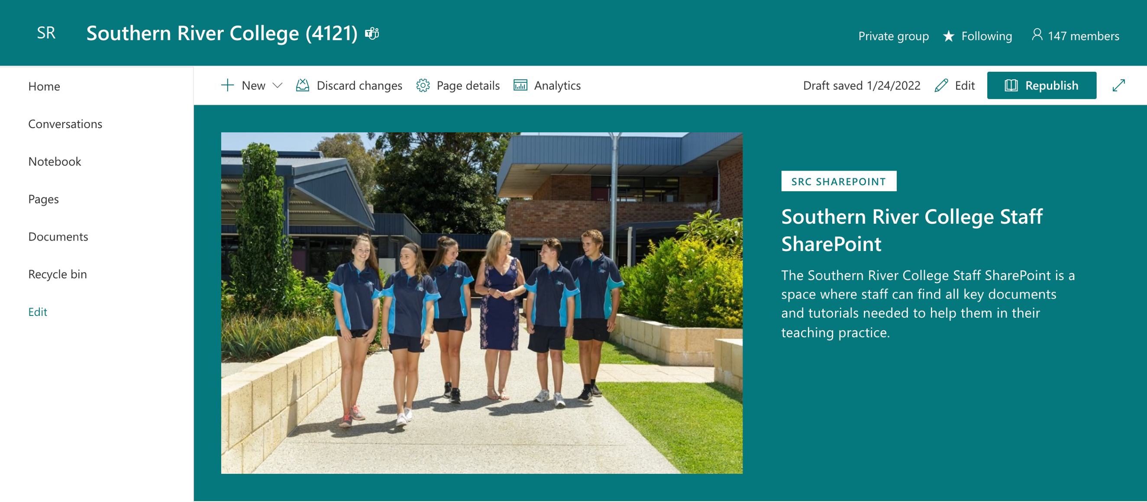

Once in the Community Select the Library Tab for any additional information you require about the College, as well as updated information on events/activities across SRC (ie NAPLAN or exam scheduling)

<https://educationwaeduau.sharepoint.com/teams/4121.AllStaff.Team/SitePages/TrainingHome.aspx>

* 1. **COST CENTRE MANAGEMENT**

When purchasing goods or services for the College you must have the approval of your Cost Centre Manager (usually your HoLA).

If you are a Cost Centre Manager or have the approval of your Cost Centre Manager to purchase goods and services, please follow the Cost Centre Management Procedures located on the College’s connect community.

<https://educationwaeduau.sharepoint.com/teams/4121.AllStaff.Team/Shared%20Documents/Forms/AllItems.aspx?id=%2Fteams%2F4121%2EAllStaff%2ETeam%2FShared%20Documents%2FFinance%20%26%20MCS%20Documents&viewid=448a6ada%2D2d6a%2D4717%2Dabd4%2D99689e26f03b>

**CURRICULUM**

* 1. **OVERVIEW**

At Southern River College we believe inspiring teachers are ones that build effective relationships with students and understand their core needs. We want our teachers to immerse themselves in best practice, building a culture that uses effective teaching and learning strategies. We want our teachers to understand their curriculum content and know how to teach it. Our teachers plan for positive and effective learning experiences by:

* Developing pathways for learning by organising the content and curriculum
* Structuring lessons using explicit and instructional strategies
* Creating environments that show positive conditions for learning.
* Reflecting on and analyse their impact on student learning
* Sharing and collaborating how to improve teaching and learning outcomes
* Using technology and communication as part of our process for learning

The Curriculum a Southern River College is complex and diverse and made up through different facets of education. Below are some of the more critical elements that make up the Curriculum components at SRC.

* 1. **EXPLICIT DIRECT INSTRUCTION – Overview**

Explicit Direct Instruction (EDI) is a framework for delivering effective educational lessons across the College. The framework was trialled in 2017 with Year 7 teachers and then in 2018, Year 12 ATAR. Its use is now an expectation in all Year groups that EDI is taught in classroom especially, Years 11 & 12 ATAR courses.

It’s ok if you do not know much about EDI, there are champions around the school who can teach you how to use the framework and adapt it to your learning area. It is also encouraged that you trial EDI practices in your classroom as the EDI framework will become the consistent teaching framework used across the College.

#### DEFINITION

“Explicit Direct Instruction, shortened to EDI, is a strategic collection of instructional practices combined together to design and deliver well-crafted lessons that explicitly teach content, especially grade-level content, to all students. EDI always includes specific lesson delivery strategies. EDI always includes continuous Checking for Understanding to verify that students are learning during the lesson. 80% Correct answers during Independent Practice. Components of EDI: Learning Objective, Activate Prior Knowledge, Concept Development, Skill Development, Lesson Importance, Guided Practice, Lesson Closure, Independent Practice. Strategies that are used with less delivery include Checking for Understanding, Explaining, Modelling, Demonstrating.” (J Hollingsworth, S Ybarra, *Explicit Direct Instruction. The Power of the Well-Crafted, Well- Taught Lesson*, London, Corwin Press, 2009, pg 12-13)

#### RESOURCES

* *Explicit Direct Instruction, The Power of the Well Crafted, Well Taught Lesson* J Hollingsworth & S Ybarra is available in the library
* The EDI Coaches Team have experience in teaching EDI. They can offer you support or point you in the right direction of staff that can assist you in your learning area
* You can also access the SRC CurrciuIum community which has more resources- <https://educationwaeduau.sharepoint.com/teams/4121.AllStaff.Team/Shared%20Documents/Forms/AllItems.aspx?id=%2Fteams%2F4121%2EAllStaff%2ETeam%2FShared%20Documents%2FSRC%20CURRICULUM&viewid=448a6ada%2D2d6a%2D4717%2Dabd4%2D99689e26f03b>

“This refers to a group of leaders and/or teachers visiting multiple classrooms at their own or another school with the aim to spread practice and support scaling up systemic improvements of teaching and learning. “ Australian Institute for Teaching and School Leadership Ltd, Instructional Rounds, 2017 (website), <https://www.aitsl.edu.au/tools-resources/resource/instructional-rounds>

SRC has just begun to formalise the process of Instructional Rounds. This work will be continued and consolidated in 2021

#### INSTRUCTIONAL ROUNDS

* 1. **ASSESSMENT OUTLINES & PROGRAM OUTLINES**

Your Assessment Outlines and Course Outlines must match the SCSA requirements. Your HoLA will provide you with guidance for your outlines and check to make sure that your outlines meet the needs of your learning area. To further assist you with your assessment and course outlines you can access the School Curriculum and Standards Authority ([www.scsa.wa.edu.au](http://www.scsa.wa.edu.au/)). You should also be registered for SCSA’s extranet to access additional materials and resources

Assessment and Course Outlines must be provided to students for your subject area. This is covered in the Connect Classes section where you are required to upload your outlines to your connect class. As well as this, your HoLA will provide you with deadlines as to when Assessment Outlines and Course Outlines are required to be submitted to Connect and to SCSA.

More information is available on the SRC Share Point

SEQTA Splashpage > SRC Sharepoint >Curriculum

<https://educationwaeduau.sharepoint.com/:f:/r/teams/4121.AllStaff.Team/Shared%20Documents/SRC%20CURRICULUM?csf=1&web=1&e=z4mrQp>

* 1. **REPORTING TO PARENTS (RTP) and DATA ENTRY**

A requirement at SRC is to ensure that your Assessment Outlines are set up in RTP and that you are entering data on a regular and timely basis.

Please refer to the ICT Support Documentation if you require information on how to set up an Assessment Outline for your classes in RTP.

SEQTA Splashpage > SRC Sharepoint >Curriculum

<https://educationwaeduau.sharepoint.com/:f:/r/teams/4121.AllStaff.Team/Shared%20Documents/SRC%20CURRICULUM?csf=1&web=1&e=z4mrQp>

* 1. **SENIOR SCHOOL SCSA REQUIREMENTS**

All ATAR & General Course Assessment and Course Outlines need to reflect the requirements of the SCSA curriculum for your area. In most cases your Assessment and Course Outlines should be a direct reflection of the sample outlines on SCSA’s website. This is highly important particularly as Year 11 and 12 courses are audited by SCSA. We wish to ensure that across the College all courses are aligned with the requirements of the Western Australian Curriculum.

For specific information relating to your subject area access the Syllabus and Support Materials tab at SCSA’s website (<https://senior-secondary.scsa.wa.edu.au/>)

Your Assessment and Course Outlines will be required to be placed on Seqta Teach, provided to your HoLA for approval and also examined by a Deputy Principal.

* 1. **LOWER SCHOOL & SENIOR SCHOOL ASSESSMENT POLICY**

It is important that when it comes to assessments both staff and students follow the Assessment Policy. The most updated version of the Assessment Policy can be located on the SRC Curriculum SharePoint page (Sharepoint →SRC Curriculum →Assessment Policy). Staff should use the Assessment Policy to consider when a student has or hasn’t done the right thing in terms of assessment and to notify your HoLA and Deputy of Curriculum when you believe the integrity of an assessment has been compromised.

A copy of the Assessment Policy (lower/senior dependent upon the class) should also be placed on your class Connect page so that students and parents can readily access the policy.

If you would like to explore the Assessment Policies further they are located in the SRC Sharepoint Library.

SEQTA Splashpage > SRC Sharepoint >Curriculum

<https://educationwaeduau.sharepoint.com/:f:/r/teams/4121.AllStaff.Team/Shared%20Documents/SRC%20CURRICULUM?csf=1&web=1&e=z4mrQp>

* 1. **EXAM, EST, OLNA, NAPLAN TESTING**

Part of the duties of being a teacher at SRC are to administer and be a supervisor for college, state and national testing. Prior to each test a series of protocols will be sent out that need to be followed by invigilators for any of these types of assessments.

Common guidelines for invigilators across all types of test are:

* + - Check test/exam scheduling documentation carefully noting the days and times you are required for supervision. Be timely for your supervision which will enable you enough opportunity to collect test papers (or set out laptops) and set out testing room if required.
    - There are two attendance roles with any test/exam. One is to be sent to **WELL BEING CENTRE** via an exam Rover. The other needs to remain with the test papers and be returned to the **administration office with all of the test papers.**
    - Check the exam room on arrival, make sure desks are set out in single file and distribute papers (or laptops) on each desk before students enter. Place an appropriate time breakdown on the board for students to refer to, 15 minute increments. Please remember to adjust/cross off as time progresses
    - As students arrive make sure they are adhering to their instructions regarding bags, phones, equipment, food & drink etc. and allow students to be seated. Students are to place their bags at the front of the classroom and should not have their mobile phones on them (they should be turned off and in bags). **No music/headphones are permitted at any stage and all hats/hoodies need to be removed for the duration of the exam** (unless they are performing NAPLAN online)
    - Read through student instructions and reiterate “Silence” at all times. Should a student require assistance, they are to raise their hands and wait for a response. Noisy/disruptive behaviour will result in immediate removal. Should a student require removal, the supervisor will signal the Rover and the offending student will be removed from the test/exam room. The offending student’s test/exam is then crossed and notes regarding the incident documented on the attendance sheet. The supervisor must then make a phone call home to inform parents/guardians of the incident that has occurred.
    - Reading time is precisely that; no notes are to be made during this time.
    - Supervisors cannot answer questions related to the content in a test/examination
    - No student is permitted to leave before the scheduled finish time.
    - No food is to be taken into the classroom.
    - Water in a clear plastic bottle is permitted.
    - At the conclusion of the test/exam, all students are to remain seated until all testing papers have been collected (or students have logged off laptops). Students leave the room only when instruction has been given by the supervisors. Students do not take away any part of the papers
    - Test papers are returned to the administration office (or notes in the case of online testing)

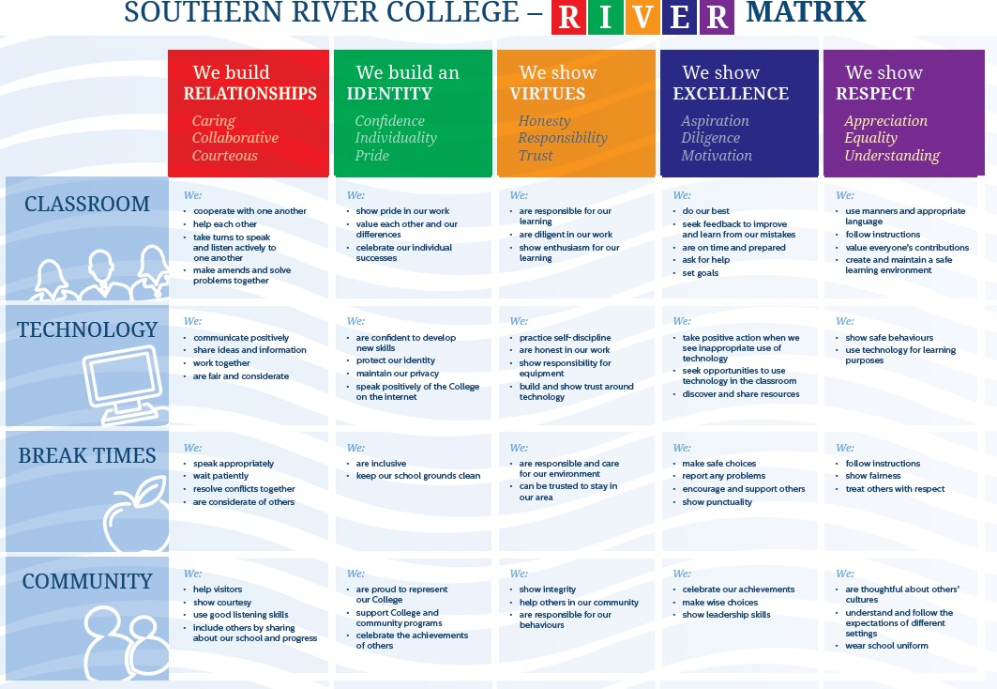

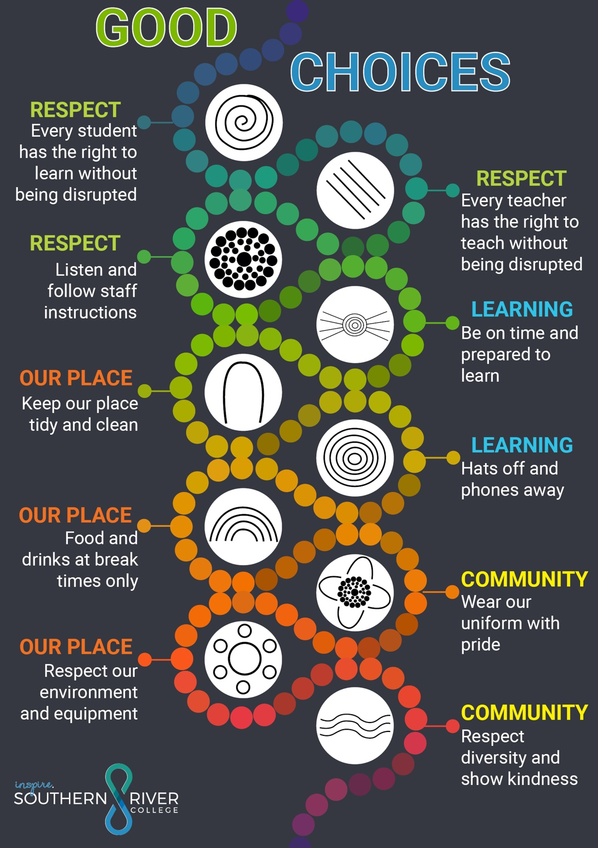

#### SUBSTITUTION AUGMENTATION MODIFICATION REDEFINITION (SAMR)

The SAMR model is utilised by all staff at Southern River College to embed technology within good pedagogy. The model was developed by Dr Ruben Puentedura and aims to support teachers to design, develop and integrate learning technologies to support high levels of learning achievement.

The model itself describes four levels of technology integration that increases in complexity and effect, from simple substitution which barely changes the function, to a more complex redefinition where the technology use can provide opportunities to create what would not be possible without that technology.

The ICT committee provides a lot of support and professional development around SAMR and your learning area representative should be the person you get in contact with if you wish to learn more or progress your pedagogy using the SAMR model.

Southern River College has a Student Owned Laptop Program (SOL) which allows parents to purchase specific devices for their students to use at SRC. Staff are required to embed ICT use into their curriculum delivery and encourage students to bring their POLP devices to school to use.

Staff are encouraged to utilise the Office 365 apps available to staff via the DoE Portal. For more information and assistance on how to use Office 365 you will be added the Staff Notebook – ICT @Southern River College. Information is also available on Connect.

For assistance with ICT Curriculum please contact Owen- DAVIES Caradoc [Southern River College]

* 1. **ICT CURRICULUM, POLP, OFFICE 365**
  2. **COMMITTEES**

|  |  |  |  |
| --- | --- | --- | --- |
| There are a variety of committees that make positive impacts at SRC. These committees are professional learning communities, positive behaviour support at SRC and operational matters that occur within the College. If you would like to be a part of a committee nominations are called by the Principal at the start of the year.  Below are the professional committees and communities that exist at SRC that you can be a part of: | | | |
|  | Alumni Committee | Parents and Citizen Committee |  |
|  | Building & Works Committee | Wellbeing/BeYou Committee |  |
|  | Community Garden Committee | Pedagogy Committee |  |
|  | English As A Second Language Committee linked to the Pedagogy Committee | School Board |  |
|  | Finance Committee | STEM Education/Minerals and Energy Committee |  |
|  | Information Communication & Technology  Committee | Workload Advisory Committee |  |
|  | Occupational Health & Safety |  |  |

* 1. **PROFESSIONAL DEVELOPMENT**

Staff are encouraged to attend Professional Development opportunities that help to enhance their teaching practice or contribute to the positive life of the College. When applying for a professional development opportunity within College hours or funded by the College, the professional development must link to the College’s priorities and targets within the business plan.

To apply for Professional Development please fill out the form located in the staff support section. Once completed and signed by HoLA, take this form to the HR Officer. The Deputy Principal of Curriculum will then assess the application and provide the final approval for you to attend the learning opportunity.

**WELL BEING CENTRE**

* 1. **WELL BEING CENTRE STRUCTURE (SUPPORT SERVICES & STAFF)**

The Well Being Centre team at SRC works hard to provide additional support to students who require it. If you have concerns for a student and their education, then a Student At Educational Risk (SAER) form should be filled out and submitted to Student Services. From here the Student Service team will investigate your concern further and follow up with that particular student (SAER referrals are available on Connect).

Although the team does provide support with student behaviour they are not your first port of call for assistance. Teachers are responsible for student behaviour in their class and should use all the classroom management strategies they have to maintain a safe and productive learning environment. If a teacher is unable to establish/maintain this environment, then they should seek advice and support from their HoLA first. There are further support strategies and processes highlighted in the Behaviour Management Policy. Before asking Student Services for assistance these other options should be investigated.

#### Well Being Team and their role:

|  |  |
| --- | --- |
| Head of Well Being | Mr Nathan Trengove |
| River Road Manager | Ms Linda Daniel |
| AEIO | Mr R. Kickett |
| Chaplain | Mr Wynn |
| Psychologist | Ms Tabitha Woods |
| Year 7 Coordinator | Ms K Clegg |
| Year 8 Coordinator | Mr J Arlidge |
| Year 9 Coordinator | Mr K Allen |
| Year 10 Coordinator | Mr Macpherson |
| Year 11/12 Coordinator | Mrs Cunningham |
| Youth worker | Mr S Dominish |
| Triage Officer | Ms K Schmidt |
| Reception | Ms S Sale |

* 1. **BEHAVIOUR MANAGEMENT IN SCHOOLS (BMIS) OVERVIEW**

It is the responsibility of the classroom teacher to establish an environment of safety and learning for students. Teachers should utilise their Classroom Management Strategies (CMS) to create this environment and negate student behaviour that might cause disruption to it. Should a teacher’s CMS strategies be ineffectual then there are a few other processes a teacher can utilise to re-establish a positive learning environment.

The Student Service team have a flow diagram for how to deal with behaviour and how to effectively use the buddy and withdrawal system. This documentation is continually updated and is available on Sharepoint (Southern River College Sharepoint→ Welling being documents→BMiS policy and procedures.

Below is a very basic outline of how the BMiS process works.

##### SRC BMiS Steps:

CMS

* + - The teacher utilises their CMS skills to create a positive learning environment
    - The teacher utilises their CMS skills to deal with minor behaviour

BUDDY/HOLA SUPPORT

The Teacher's CMS is ineffectual and a positive learning environment cannot be established. As a result the teacher needs extra assistance to positively address the inappropriate behaviour, or help estable a positve learning environment.

* The teacher asks student disrupting the learning environment to go to another classroom and reflect on their behaviour. HoLA may be required to provide support. The teacher then follows up with the student in the appropriate way to assist the student in displaying positive behaviours next lesson. The incident is record in SIS.

WITHDRAWAL

* The teacher has used the assistance of the HoLA and the buddy class to try and assist the student in reflecting on their behaviour. The student still has not positively engaged and requires a more structured approach to reflect on their behaviour
* Student Services may provide assistance at this stage to support the teacher, HoLA and student in moving forward

Specific information on BUDDY/WITHDRAWAL and paperwork can be found on SRC’s Sharepoint <https://educationwaeduau.sharepoint.com/:f:/r/teams/4121.AllStaff.Team/Shared%20Documents/Well%20Being%20Centre%20Documents?csf=1&web=1&e=yaJ40Q>

#### CLASSROOM MANAGEMENT STRATEGIES PROGRAM AT SRC (BMiS/SNAPSHOTS)

Snapshots is an SRC version of the popular Classroom Management Strategies offered by School of Special Educational Needs. Conducted on a weekly basis for new staff or staff who wish to develop their behaviour management skills. The program provides practical classroom management strategies designed to improve student engagement and reduce unproductive social behaviour by establishing a positive, proactive classroom environment 1. The program also covers BMiS processes and procedures to help you understand how to use the College’s behaviour processes effectively.

New staff will be invited to join the BMiS Snapshots early in Term 1 and an invitation extended to other staff members who are looking to refine their behaviour management practices. Please see Kate Cunningham for more details.

1 CMS Foundation Program ([www.det.wa.edu.au](http://www.det.wa.edu.au/))

* 1. **SRC UNIFORM REQUIREMENTS (STAFF & STUDENTS)**

The College requires staff to dress professionally and appropriately at all times. This is important as it promotes your professionalism as an educator at SRC, is reflective of the teaching culture at SRC and you as a role model for students and how they represent themselves in their uniforms.

The following is a set of guidelines to assist you:

* Staff should dress appropriately and in a manner that maintains respect for our profession.
* Staff should dress appropriately and in a manner that establishes credibility.
* Male employees should wear a collared shirt.
* Professional attire for formal school or department events should be considered (i.e. parent teacher interviews, graduation, award assemblies and interactions with the community where they are representing SRC or DoE).
* Clothing should comply with relevant workplace health and safety regulations. Closed in footwear, particularly in practical areas, is required at all times.
* Revealing clothes (exposing bare midriffs, spaghetti straps/ strapless tops, leggings, jeggings etc.) that may be construed as suggestive or offensive should be saved for the weekend.
* Singlets, t-shirts, track suits, thongs (except for sport and organised activities), clothes with inappropriate slogans should be saved for afterhours.
* Facial piercings are an OS&H risk. This particularly applies to Physical Education and practical areas.
* Denim is not permitted in WA schools.

##### SRC Student Uniform

Students must wear the correct uniform to SRC. If a student chooses not to adhere to this then it is their teacher’s responsibility to record this information on Academy/SIS.

Below are the uniform guidelines that students are expected to follow. Please use these guidelines when discussing with students the need to wear correct uniform.

*Student Uniform Policy*

SRC has a compulsory uniform policy that needs to be adhered to by students. There is to be no variation to the SRC uniform, as wearing the College uniform makes it easy to identify students who attend SRC, builds a sense of belonging to the College and ensures that everyone is making the same fashion statement.

### OS&H Footwear & Piercings

Due to Occupational Safety and Health students must wear closed in shoes that protect their feet. Therefore, shoes such as thongs, sandals, ugg boots and open ended shoes shouldn’t be worn to school.

Facial piercings are an OS&H risk and are strongly discouraged, particularly where students are working with equipment, tools and machinery. Small studded earrings and hoops in the ear lobe are the only acceptable facial jewellery for students to wear. Small studs or flat faced piercings will be accepted. Providing a safe, clean and secure environment for your child is our paramount concern.

### School Uniform Requirements

Senior School polo shirt (Navy blue with sky blue sleeves) Navy blue shorts, skirts or pants

Navy blue windcheaters or navy blue jacket with College logo Enclosed footwear that conforms to safety standards

No other types of clothing (jeggings, jeans, t-shirts)



*Physical Education*

A change of shirt for hygiene reasons

Navy polo top with white sleeves and College logo

**STAFF DEVELOPMENT & WELLBEING**

* 1. **AITSL STANDARDS & PERFORMANCE MANAGEMENT**

As a professional educator you are required to meet set standards of teaching. To inform you of your practice and to ensure that you continue to develop as a professional, the College performs performance management/development with all staff. These are conducted with your HoLA or Deputy Principal and relate to AITSL standards and the professional teaching expectations set out by TRB.

To access the standards for teaching and self-reflection tools please go to the AITSL website. <https://www.aitsl.edu.au/>

For more information on SRC’s performance management/development process head to the SRC Connect Community or discuss this with your HoLA.

SEQTA Splashpage > SRC Sharepoint >Curriculum

<https://educationwaeduau.sharepoint.com/:f:/r/teams/4121.AllStaff.Team/Shared%20Documents/SRC%20CURRICULUM?csf=1&web=1&e=z4mrQp>

* 1. **PERSONNEL TO SEE**

|  |  |  |  |  |
| --- | --- | --- | --- | --- |
| Here is a quick guide of staff to see when you are looking for more information | | | | |
|  | **STAFF MEMBER** | **ROLE** | **SPECIFIC SUPPORT THEY PROVIDE** |  |
|  | Everal Eaton | Principal | |  |
|  | Frank Di Filippo | Deputy Principal Operations | HR, Well Being Centre, Staff & Student Wellbeing at SRC, |  |
|  | Owen Davies | Deputy Principal STEM & Entrepreneurships | SEQTA, Computer Lab Scheduling, Connect, Digital Technologies, ESTs, Exams, ICT, ICT Curriculum, Operational Policy and Procedures, NAPLAN, OLNA, SAMR, SIS/ RTP Support, SRC Handbook and Resources, Staff Inductions Documentation,  Surveys, WACE Tracker 11s/12s, and Timetabling |  |
|  | Sharon Harry | Deputy Principal Curriculum | SRC Curriculum, Teaching &  Learning, Senior School, SCSA, TRBWA  Student Services, Aboriginal Cultural Framework, Aurora Project,  PBS, SEEC |  |
|  | Sarina Cooper | Manager of Operations | ESTs, Exams SEQTA, NAPLAN, OLNA, Inspire and Timetabling, Pat Testing |  |
|  | Brian Hand | Manager of Corporate Services | Building & Faults, Finance, Keys,  Non-Teaching Staff, School Board |  |
|  | Linda Daniels | River Road Manager | Complex Behaviours, Student  Services Support, SAER |  |
|  | Nathan Trengove | Manager of Wellbeing | Provide positive school culture and wellbeing leadership. Continue to develop, refine and promote the Southern River College RIVER values. |  |

|  |  |  |  |  |
| --- | --- | --- | --- | --- |
|  | Tricia Hatch | HoLA of Maths | Maths |  |
|  | Lesley Stace | HoLA of English | English |  |
|  | Robert Forte | HoLA of Science | Science |  |
|  | Clare Woulfe | HoLA of HASS | HASS |  |
|  | Linda Daniels | HoLA of SALP | SALP program |  |
|  | Ashley Meaden | HoLA of Arts | Arts, Arts Festivals, Music Concerts |  |
|  | Roze Cole | HoLA Technologies | Food Technology, Digital Tech, Design & Tech (Woodwork etc) |  |
|  | Darren Smith | HoLA STEM | STEM |  |
|  | David Toothill | Coordinator of VET | Career Advice, Coordinator and Certificate II Courses, External Certificate Courses, GETIL, Try a Trades, VET |  |
|  | Patt Warr | Head of Physical Education | Health, Physical Education |  |
|  | Cathy Hayward | Curriculum Support Officer | DAM, Enrolments, ESTs, Exams, PTO, Reporting, RTP/SIS, SCSA  Uploads, SIRS, SSO, Timetabling |  |
|  | Mel Lee | Finance Officer | Finance, Purchase Orders/Cards, QKR, Licences, Hire of Facilities, Budgets |  |
|  | Rachel Blundell | HR Officer | Excursion Packs and Forms, Relief Coordinator, Staff  Payroll, Yearbook, Contracts/Recruitment Assist |  |
|  | Brian Hand | Manager of Corporate Services |  |  |
|  | Shiarne Coole | Library Officers | Facebook Page, Library Support, Moodle Bookings, Media  Stories |  |
|  | Julie Hughes | Principal’s PA & PR/Marking | Principal’s Secretary, Marketing, Newsletter, |  |
|  | Tanika Bluett | Enrolment and Front Officer | Reception, Faults, Daily Notices, Receipting Enrolments, Reception support, Purchase Orders/cards & Payments, Keys |  |
|  | Sharon Sale | S/Service Administration Officer | Attendance, Absentees, S/Service  Support |  |
|  | Blair Pasco | Aboriginal Program Support | Aboriginal Cultural Framework,  AIME, Aurora Project |  |
|  |  | DSG Coordinator | DSG Program |  |
|  | Charlotte Donovan and Lesley Stace | Teacher | EALD |  |
|  | Staff – led by Sharon. Harry | Pedagogy Learning Community Team | Teaching Pedagogy Support |  |
|  | Matt Burnett and Rod Sutton | IT Technicians | IT Support |  |
|  | Selwyn Williams | HASS Teacher | Student Council |  |
|  | Gayle Page | Arts Teacher | Union Representative |  |
|  | Kylie Clegg | Transition Coordinator | Provide management of transitions to all programs |  |
|  | Dale Watkins and Alisha Moicevich | Case management and Complex Behaviour Support | Tier 3 student support |  |
|  | Lisa Scott-Harmer, Katie-Jayne Tirkot, Kira Pearce and Tessa Devenyns | Head of House | Overseeing house development and competition. |  |

* 1. **TAKING LEAVE**

There are different types of leave that can be utilised by staff where required. It is important to inform the College of your absence if you are going to take leave and that you have gained the proper permissions to be absent from school depending on the type of leave you have taken.

**SRC SICK LINE – 0419 194 605** – TEACHING STAFF ONLY

#### SICK/EMERGENCY

**Please TEXT the SRC Sick Line if you are unable to come to work.** Emails are not monitored outside of work hours.

The HR Officer works on-call and is contactable during the following times; Evenings: 6.30pm – 8.00pm

Mornings: 6.30am – 7.00am

Email lesson plans to ] [Rachel.Blundell@education.wa.edu.au](mailto:Rachel.Blundell@education.wa.edu.au) using the Relief Lesson Plan template. Only staff absent due to sick/emergency overnight may email relief work through for printing/photocopying.

#### PLANNED LEAVE

**PRE-BOOKED MEDICAL APPOINTMENTS / SHORT LEAVE / LSL / BEREAVEMENT / EXCURSIONS / P.D. OR ANY ABSENCE YOU HAVE HAD NOTICE OF.**

If you have a planned absence, notify the HR Officer as soon as is practicable. Absences for PD or Excursions

**will not** be processed without the correct paperwork. Short Leave **MUST** be approved by the Principal.

All relief work for planned absences needs to be pre-printed by the teacher before the absence occurs. All relief work for planned absences needs to be left on the HR Officer’s desk **prior to 7am** on the day of your absence.

#### *This is inclusive of relief required for individual meetings/observations through-out the day*

|  |  |  |  |  |  |  |  |  |  |  |
| --- | --- | --- | --- | --- | --- | --- | --- | --- | --- | --- |
| **LEAVE CHEAT SHEET (Teaching Staff)** | | | | | | | | | | |
| **Type** | **What is this leave for?** | **Number of Days** | **How many can I claim?** | **Do I need to accrue this**  **leave?** | **When do I accrue the next amount?** | **Does this roll over each year?** | **Do I need Evidence?** | **What counts as Evidence?** | **Full day? Half day?** | **Special Req** |
| **Sick –**  **No Cert** | Sick Days | 5 per year | 2 in a row | Yes. Sick Leave Credits | Anniversary of Employment.  Noted on your payslip. | Yes | No | n/a | Full or Half only | Cannot claim on either side of School/Public Holidays without  evidence. |
| **Sick - With Cert** | Sick Days or Medical appointments | Up to your accrued amount.  Noted on your  payslip. | As many days as you have credits. | Yes | Doctors Cert / Letter Of Attendance / Specialist Referral/ Hospital paperwork/ Dentist Cert etc. | Full or Half only | Evidence must note **your name, the date and Doctor's/Dentist's name.** |
| **Family Carers** | Caring for family member | 12.5 per year | 12.5 days | No | Yes. Medical Cert or your own written explanation. | Brief note explaining absence or a Doctors Cert/ medical paperwork. | Full or Half only | You need sick leave credits first, to claim carers leave. |
| **Short Leave** | **URGENT**  **(unplanned)** private business to be conducted during work  hours. | 3  instances | 3  instances per year whether half or full day. | No | n/a | No | Yes | Brief note explaining absence or proof of appointment. | Any increment | Approval at Principal's discretion. Advance notice required where possible. |
| **Bereavement** | Funeral Attendance. | 5 days per death | | n/a | | No | n/a | Any increment | Available for death of Immediate Family and Extended Family. Or at Principal's  discretion. |

|  |  |  |  |  |  |  |  |  |  |  |
| --- | --- | --- | --- | --- | --- | --- | --- | --- | --- | --- |
| **Jury Duty** | Jury Duty | Attendance is mandatory. Does not affect your leave balances | | | | | Yes | A letter requesting Jury Duty | Full or Half | None |
| **Leave Without Pay (LWOP)** | Taking leave when you have no paid credits to use. | Minimum half day. Maximum of 1 year | | No | n/a | No | Yes. | Letter of explanation | Any increment | LWOP cannot be claimed if LSL is available to use. |
| **Long Service Leave (LSL)** | Long Service | 13 Weeks accrued  after 10 years continuous service. | | Yes | First accrual 10 years.  Then every 7 years afterward. | Yes. For two years. If you have not taken your LSL within two years, you will receive a  payout amount. | No | n/a | Full day or half pay. | Accrue after continuous service only. Leave needs to be used with 2 years of accrual date. |
| **Trade Union Training Leave (TUT)** | Teachers Union training | 5 per year | up to 5 days | No. | n/a | Yes. These may accumulat e over two  years only | Yes. You need to supply your Registration  for the event | E-Ticket / Booking Confirmation | Full day | You need to be a Teacher's Union Member to access TUT leave. |

**Please note that all accumulative leave entitlements are pro-rata. If you work part time, your leave will only accrue (and be claimable) to match your work roster.**

|  |  |  |  |  |  |  |
| --- | --- | --- | --- | --- | --- | --- |
| **PD**  **Attendance** | Professional Development | n/a | Yes. PD application + attachments (if applicable) | Completed PD form + overview/flyer/schedul e about PD + an E- Ticket (if applicable) | Any increment | PD attendances during school hours are subject to Admin approval. |

#### GRADUATE PLANNING DAYS & TFA TIME

Graduate teachers have a range of entitlements that they can access. For the full range of entitlements go to *det.wa.edu.au/detcms/cms-service/download/asset/?asset_id=19723581*. As part of the entitlements graduate teachers are provided with 12 days per year for planning. Four of these days are to be used for graduate modules but the other eight can be taken as the teacher requires them. Please note that when you take this leave that your dates need to be approved by a Deputy. These days should also be used for planning and professional development only and therefore relief will not be approved if there is a College priority (in house professional development) or the planning days do not meet the criteria above.

Teach for Australia teachers are provided with extra support within their timetable. 0.2 FTE in DOTT time is afforded to TFA teachers to enable them time to meet with their mentors as well as to complete their studies. If you require one of your DOTT periods to be blocked out to enable you to complete your studies please let the HR Officer know which period you are unavailable for due to your course commitment.

* 1. **RELIEF**

If you require relief for an absence, please follow the steps below:

* + 1. Plan ahead where possible to do so
    2. Notify the HR Officer as early as possible (PREFERABLY THE NIGHT BEFORE) or before 7:15am (SRC Sick Line – 0419 194 605; Phone is permanently on silent mode and the relief coordinator can be contacted in the evenings 6:30pm-8:00pm or mornings 6:30am-7:00am via SMS)

Email lesson plans to relief coordinator ] [Rachel.Blundell@education.wa.edu.au](mailto:Rachel.Blundell@education.wa.edu.au) If your absence is likely to be ongoing then notify relief coordinator immediately. If you are sick, then photocopying can be arranged

* + 1. Notify your Head of Learning Area of your absence, lesson and class information
    2. On return to school, please complete an “Absence of Leave Form”, or ask Elli for an absence form if you know of your absence in advance. Complete the leave form and return it to Elli for processing.

More information is available on the SRC Connect Community page.

Library>SRC COLLEGE HANDBOOK> SRC STAFF SUPPORT>Leave Information, Forms & Relief <https://educationwaeduau.sharepoint.com/:f:/r/teams/4121.AllStaff.Team/Shared%20Documents/Leave%20Information,%20Forms%20%26%20Relief?csf=1&web=1&e=hDnzz5>

#### RELIEF TEMPLATE

A relief template should be used when you are completing your relief lessons. This is accessible on the SRC Connect Community page.

SEQTA Splashpage > SRC Sharepoint >Leave Information, Forms & Relief

[https://connect.det.wa.edu.au/group/staff/community/library?coisp=DomainCommunity:13508078#23923_6](https://connect.det.wa.edu.au/group/staff/community/library?coisp=DomainCommunity%3A13508078&amp;23923_6)

* 1. **Employee Support Bureau Department of Education**

Where possible the College provides all the support it can to assist staff with their wellbeing. There are a times though that staff might require additional support than what the College can provide and we encourage staff in this position to not only seek support through the College but also the Employee Support Bureau.

The Employee Support Bureau is responsible for all aspects of occupational safety and health, employee well- being services and workers' compensation for all Department of Education staff. Please visit the Employee Support Bureau webpage to find out more information on how to access support services that you may require.

<http://det.wa.edu.au/intranet/employeesupportbureau/detcms/portal/>

**POLICY & PROCEDURES**

* 1. **Overview of Policies at the College and their location on the SRC Community Connect Page**

This handbook only provides a brief overview of SRC. Information and concepts within this handbook are explored further either in policy or procedures documentation. Given the enormity of the policy and procedures when combined each policy or procedure has been placed on the SRC Sharepoint page under the Staff Handbook section. If you are looking for a particular policy or procedure please check the table below for its location in the SRC Sharepoint: <https://educationwaeduau.sharepoint.com/teams/4121.AllStaff.Team/Shared%20Documents/Forms/AllItems.aspx>

* 1. **Policy & Procedure Information & Location**

|  |  |
| --- | --- |
| **POLICY & PROCEDURE** | **LOCATION ON SRC CONNECT COMMUNITY**  **PAGE** |
| Assessment Policy | SEQTA Splashpage→SRC Sharepoint →  SRC CURRICULUM→Assessment Policy |
| Attendance Policy | SEQTA Splashpage→SRC Sharepoint →  SRC CURRICULUM→Assessment Policy |
| BMiS Policy & Procedures (Buddy/Withdrawal) | SEQTA Splashpage→SRC Sharepoint →  Well Being Centre Resources |
| Bullying Policy | SEQTA Splashpage→SRC Sharepoint →  SRC Policies |
| Bushfire Procedures | SEQTA Splashpage→SRC Sharepoint →  SRC Policies |
| Cost Centre Managers Procedures (Finance Policy  Guidelines) | SEQTA Splashpage→SRC Sharepoint →  Finance and MSC |
| Electronic Devices Policy | SEQTA Splashpage→SRC Sharepoint →  SRC Policies |
| Emergency Procedures | SEQTA Splashpage→SRC Sharepoint →  SRC Policies |
| Excursion Policy | SEQTA Splashpage→SRC Sharepoint →  SRC Policies |
| ICT Policy | SEQTA Splashpage→SRC Sharepoint →  SRC Policies |
| ICT Support Documents (Academy, SEQTA, RTP, SIS) | SEQTA Splashpage→SRC Sharepoint →  Curriculum → |
| Performance Management | SEQTA Splashpage→SRC Sharepoint →  Curriculum → |
| Mandatory Reporting | SEQTA Splashpage→SRC Sharepoint →  Key Websites |